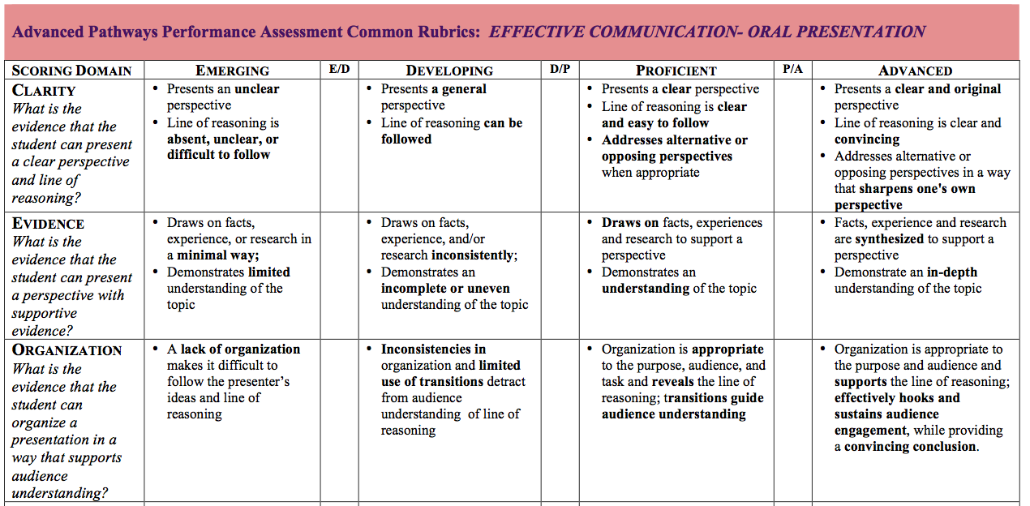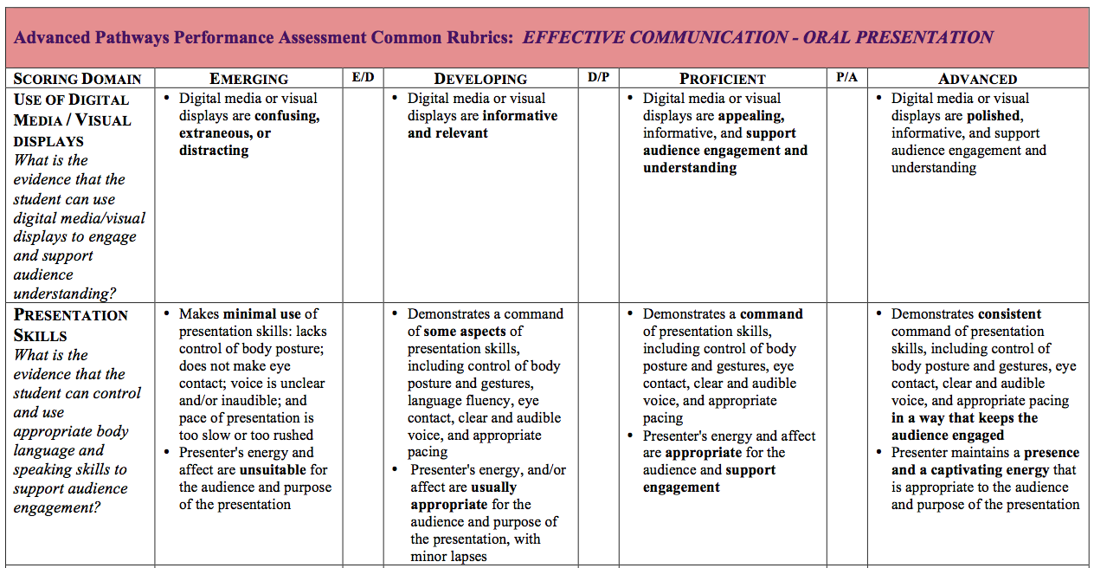

Genetically Modified Food Lobbyist Project
Scenario
You are a lobbyist who has been hired to present to a government panel that will decide whether or not to ban genetically modified foods. You will be part of a team who will research the issue and create an eight to 10 minute presentation persuading the panel to take the position that is in the best interest of your clients. Your clients have provided a list of potential resources to assist you in the preparation of this presentation. (Your teacher will provide a list for you.) You may use additional resources to build your argument as needed, but the clients have also asked that you look at the reliability of all sources used.
As a lobbyist, your job is to persuade the panel that your clients’ position is the way to go. Your lobbying team is comprised of an economist, an environmental expert, a farmer, and a doctor. Each member of the team will be expected to address their area of expertise in the presentation and explain how it specifically will be impacted by the panel choosing your clients’ position. Remember to use the training you have received in persuasion as you prepare your arguments.

Team Roles
Environmentalist: The lobbyist lens/point of view is that genetically modified food has positive effects on the environment. (Environmentalists seek to improve and protect the quality of the biotic and abiotic parts of nature. They also identify and educate the public on the ways to reduce the impacts of harmful human activities.)
Farmer: The lobbyist lens/point of view is that a farmer should either have the choice or opportunity to grow genetically modified food.
Doctor: The lobbyist lens/point of view concerns what effects consuming genetically modified foods has on human health.
Economist: The lobbyist lens/point of view is that of the effect genetically modified foods have on the economy. (Economists are concerned with financial issues. They study the impact of a specific activity or product on communities [cities, states, nations, global].)

Research Notes
Each time you read a new article/webpage, make sure to cite the appropriate source information so you will be able to produce a quality bibliography and return to the page should you need to.

Source

Notes

Should genetic modification of organisms
be allowed to continue?
Why or why not?
As you do your research, keep a list of pro’s and con’s below. You should choose the position that you can best support with evidence. Make sure you cite the sources you use.
Pro | Con
1. | 1.
2. | 2.
3. | 3.
4. | 4.
5. | 5.
6. | 6.
7. | 7.
8. | 8.
9. | 9.
10. | 10.

