Genetic Testing and Bio-Engineering | Science,  Life Science | Middle School
Common Assignment 2
LDC Argumentative Essay:
What Role Should Ethics Play in Genetic Testing or Bio-Engineering?
Table of Contents
- Teacher Materials
  - LDC Instructions, Standards, Scoring Guide, and Resources
- Modified LDC Rubric
- Student Materials
  - Instructions

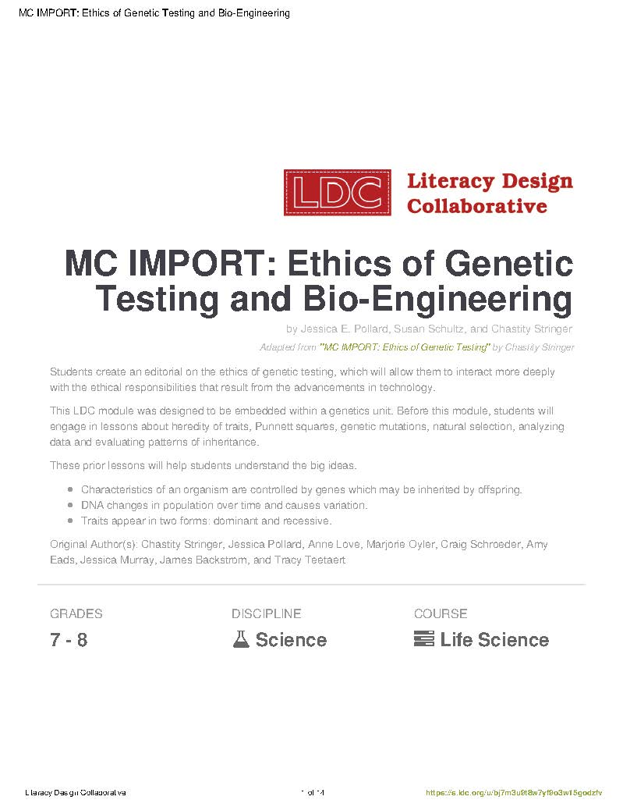

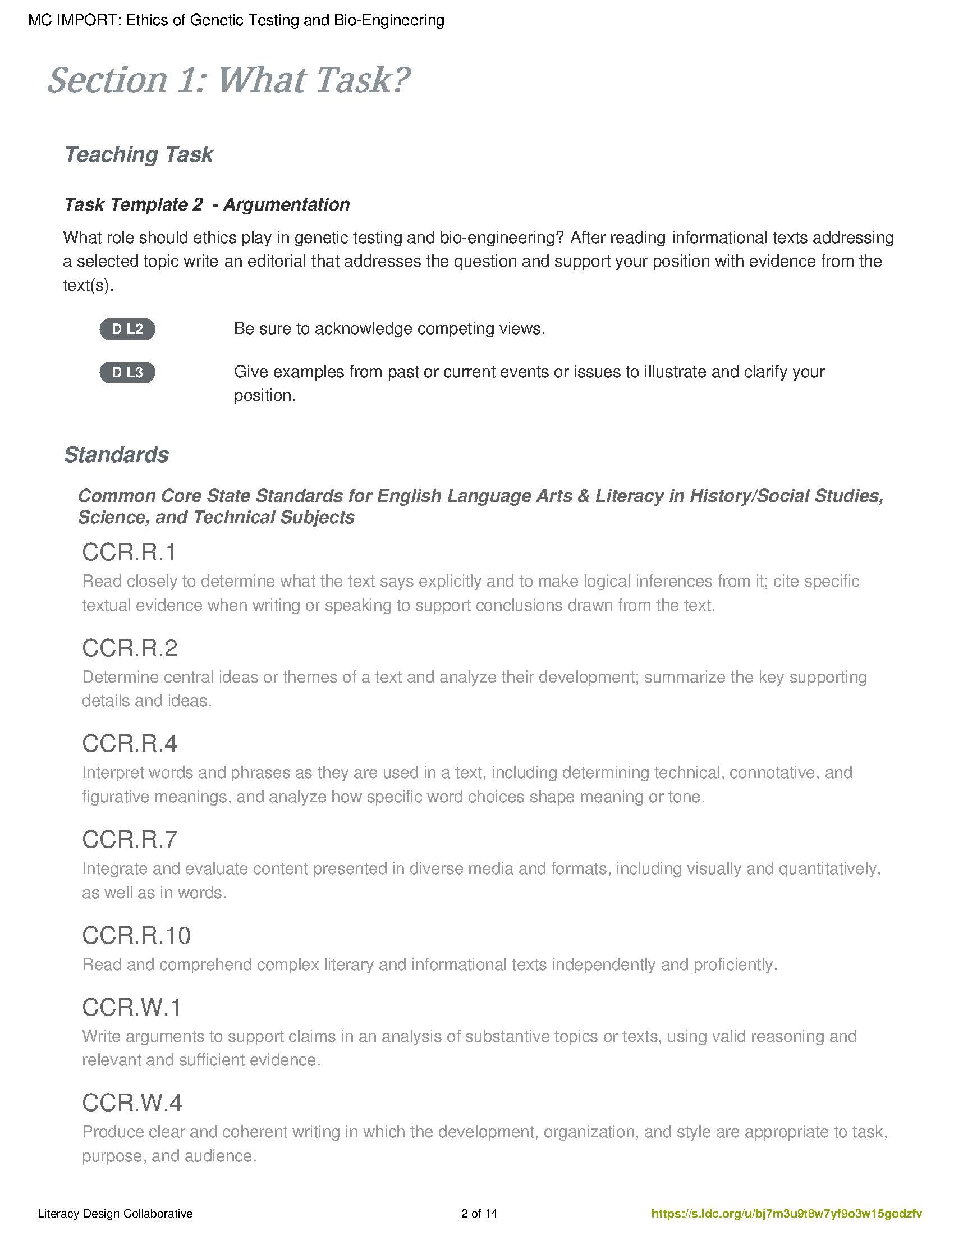

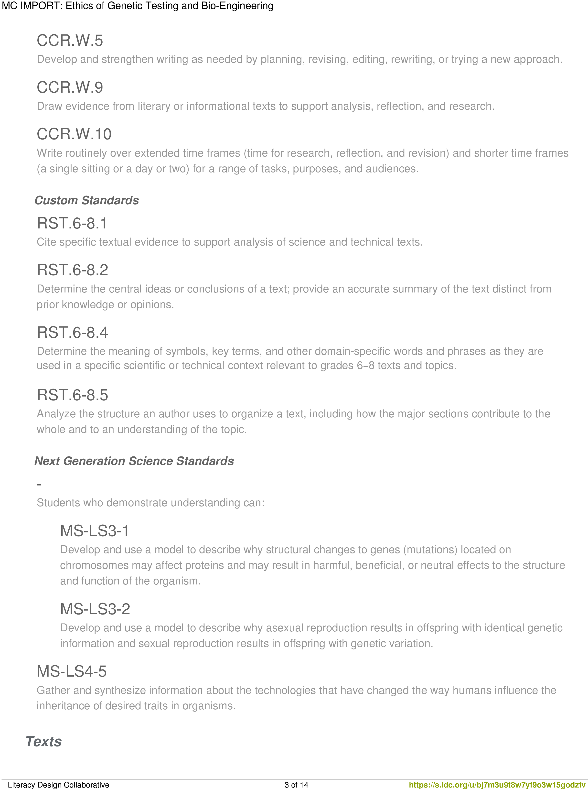

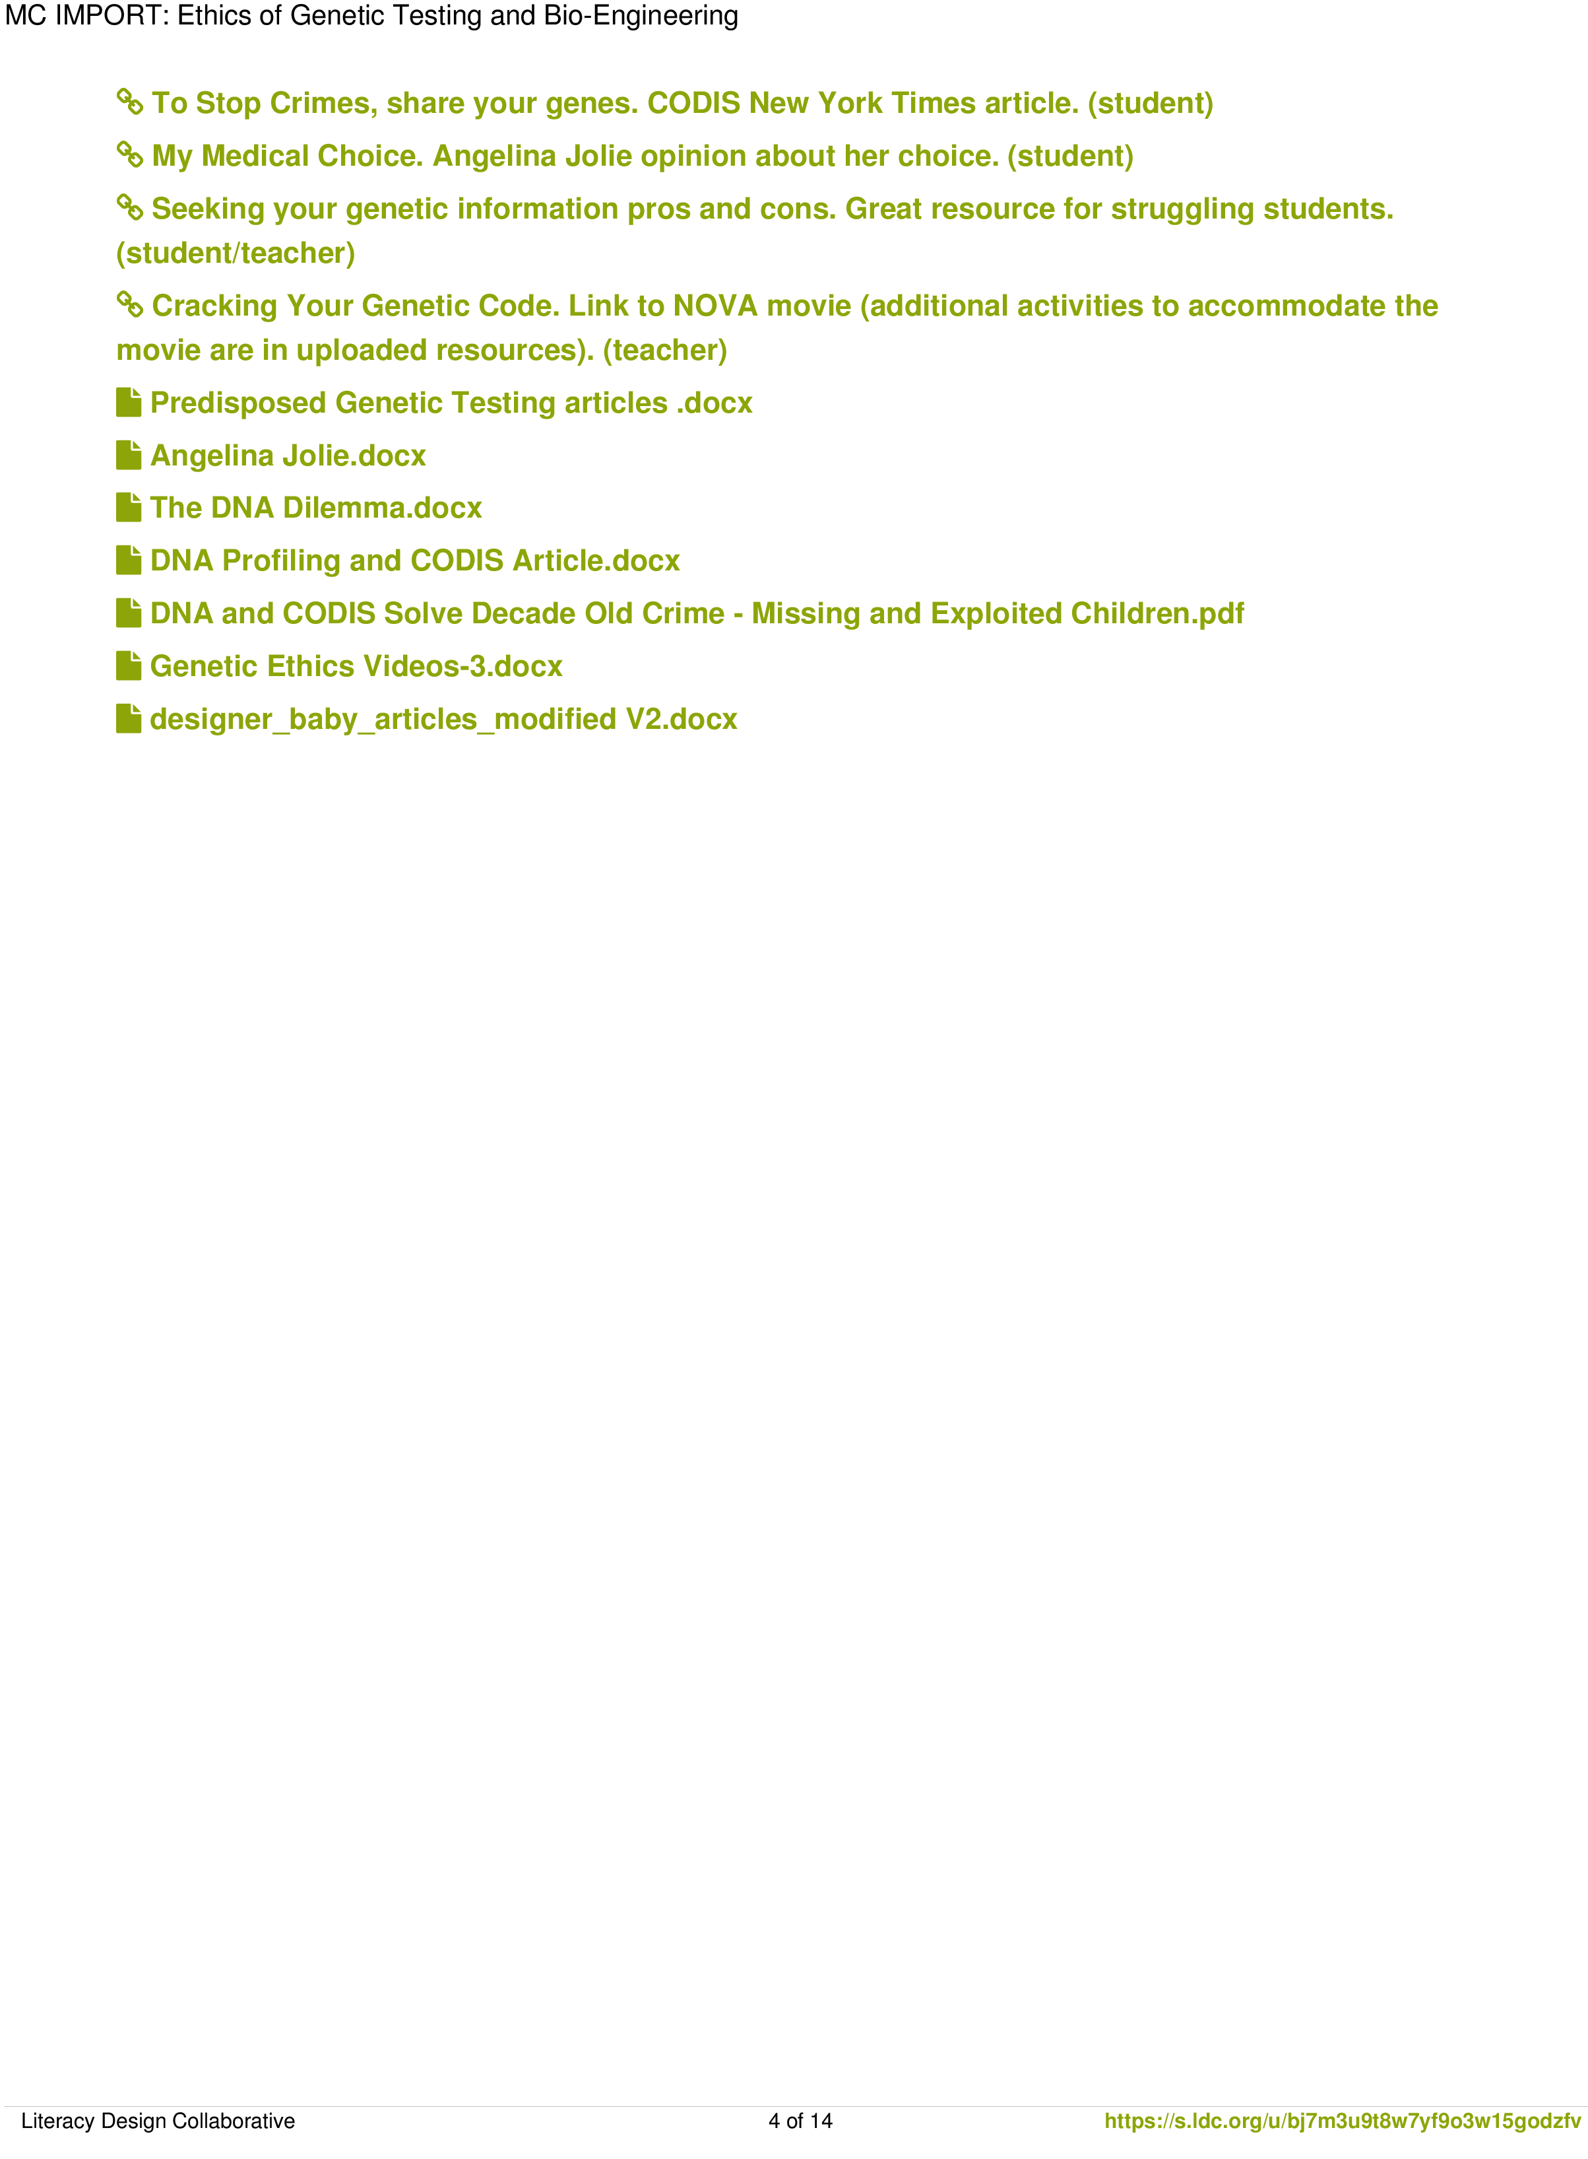

√

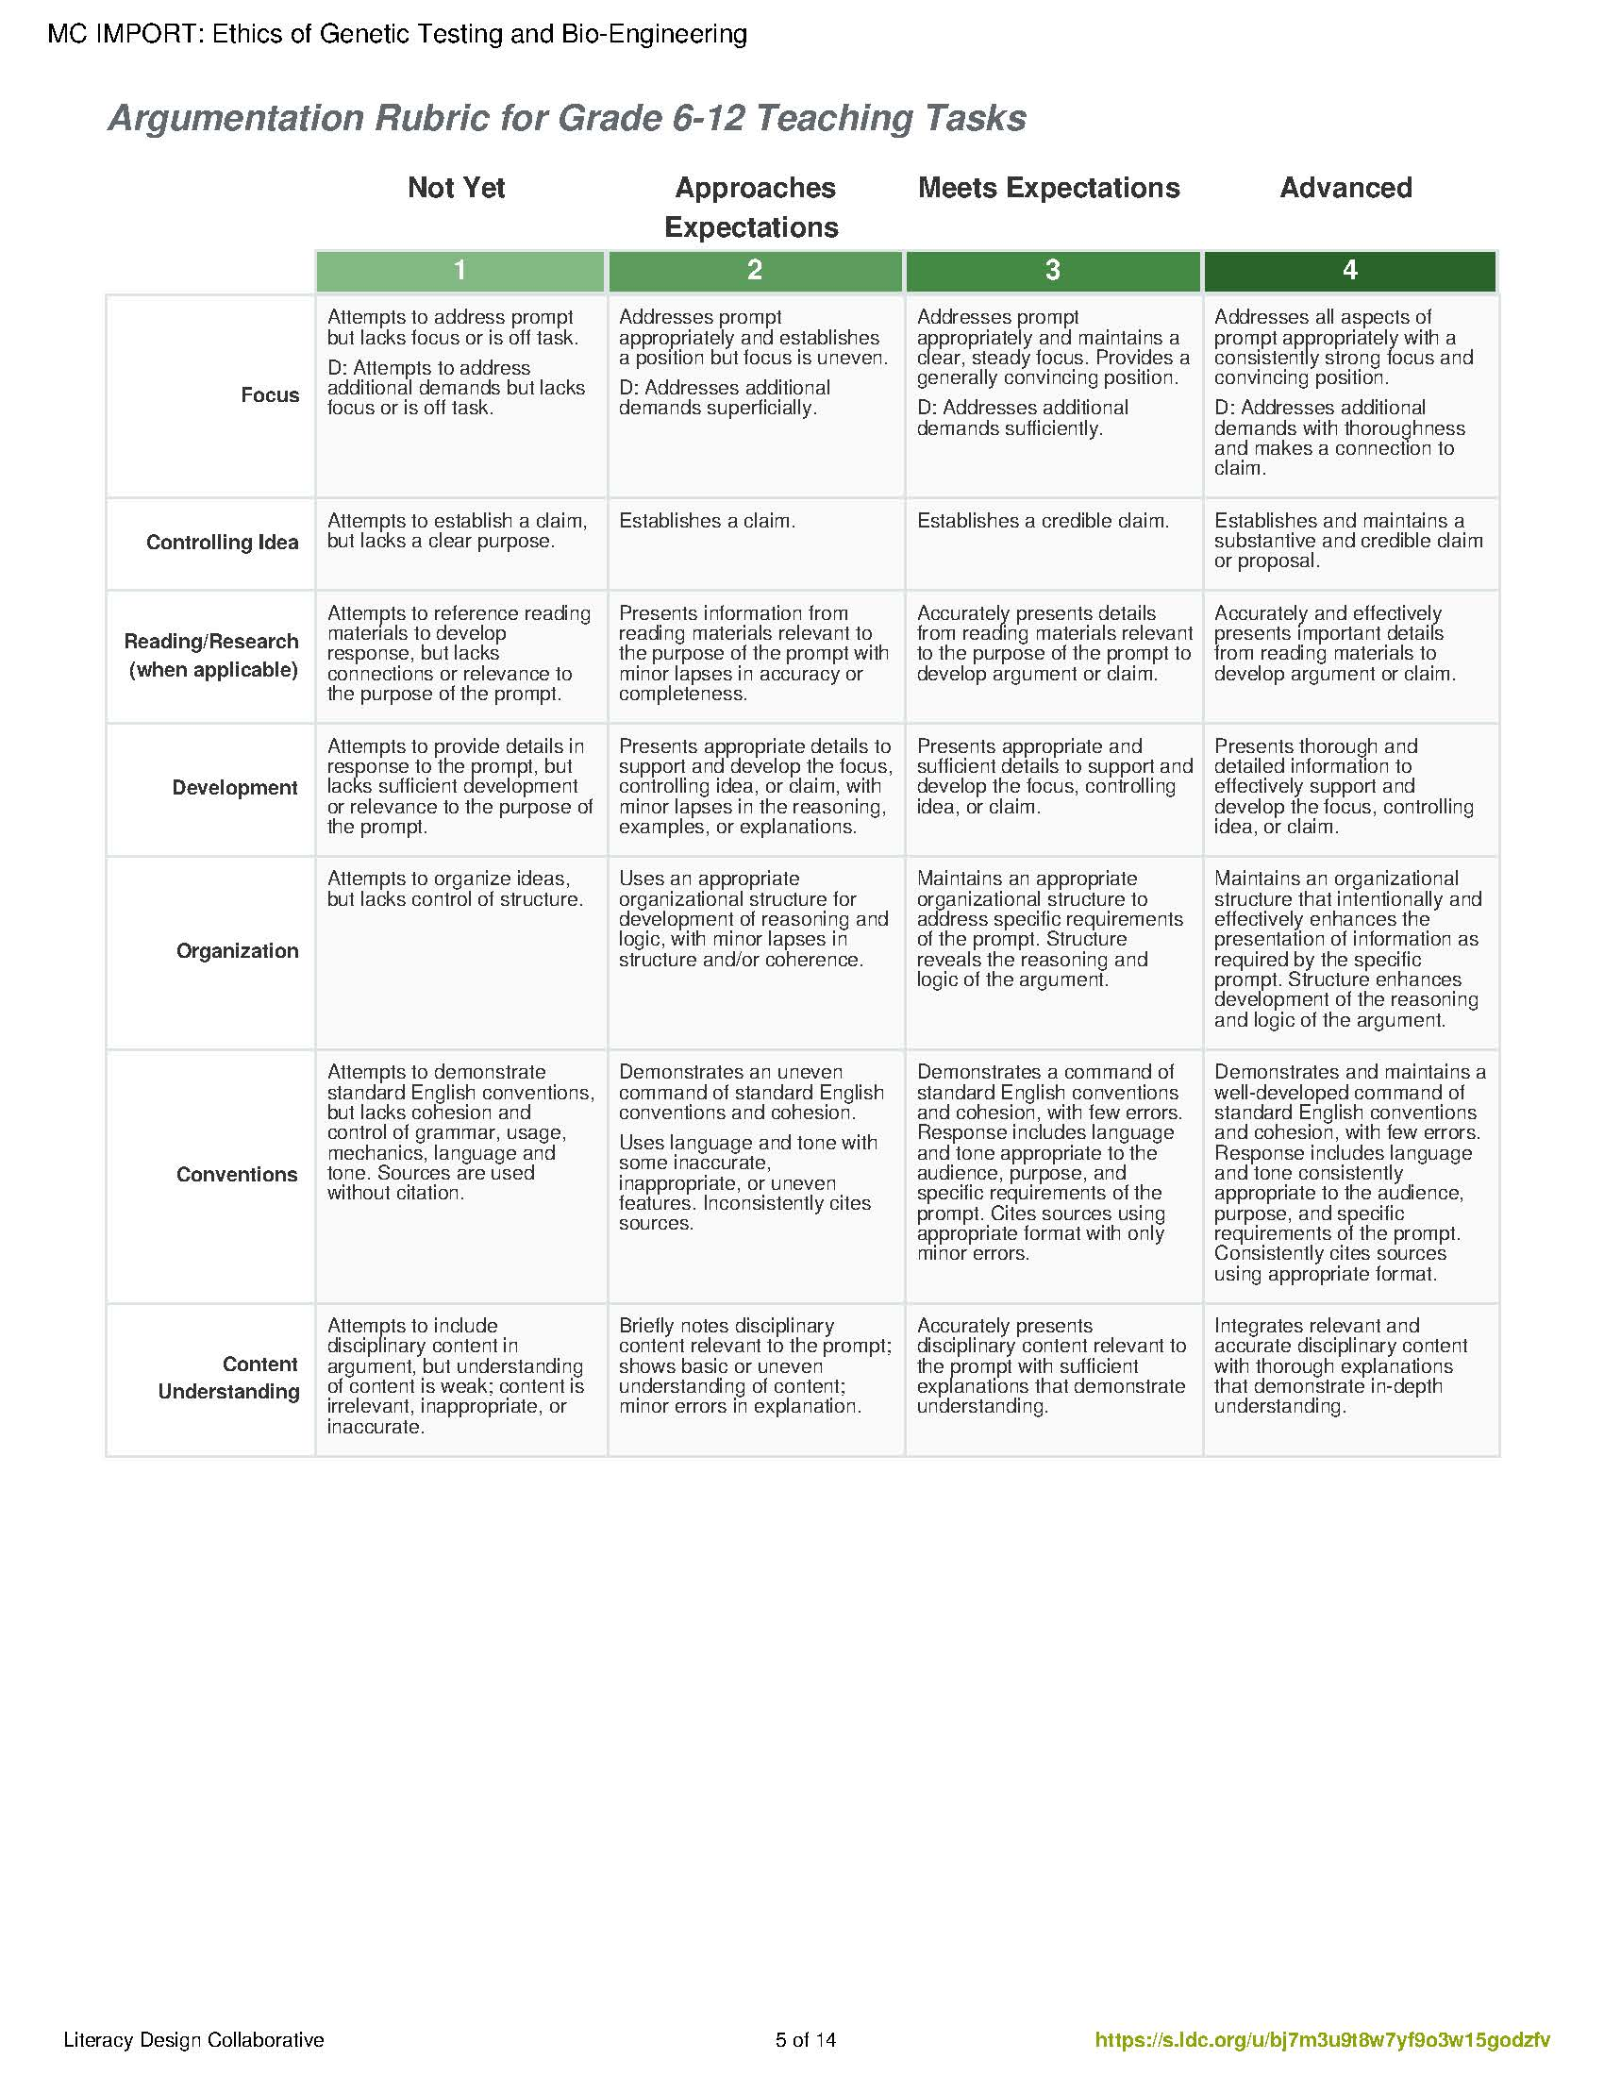

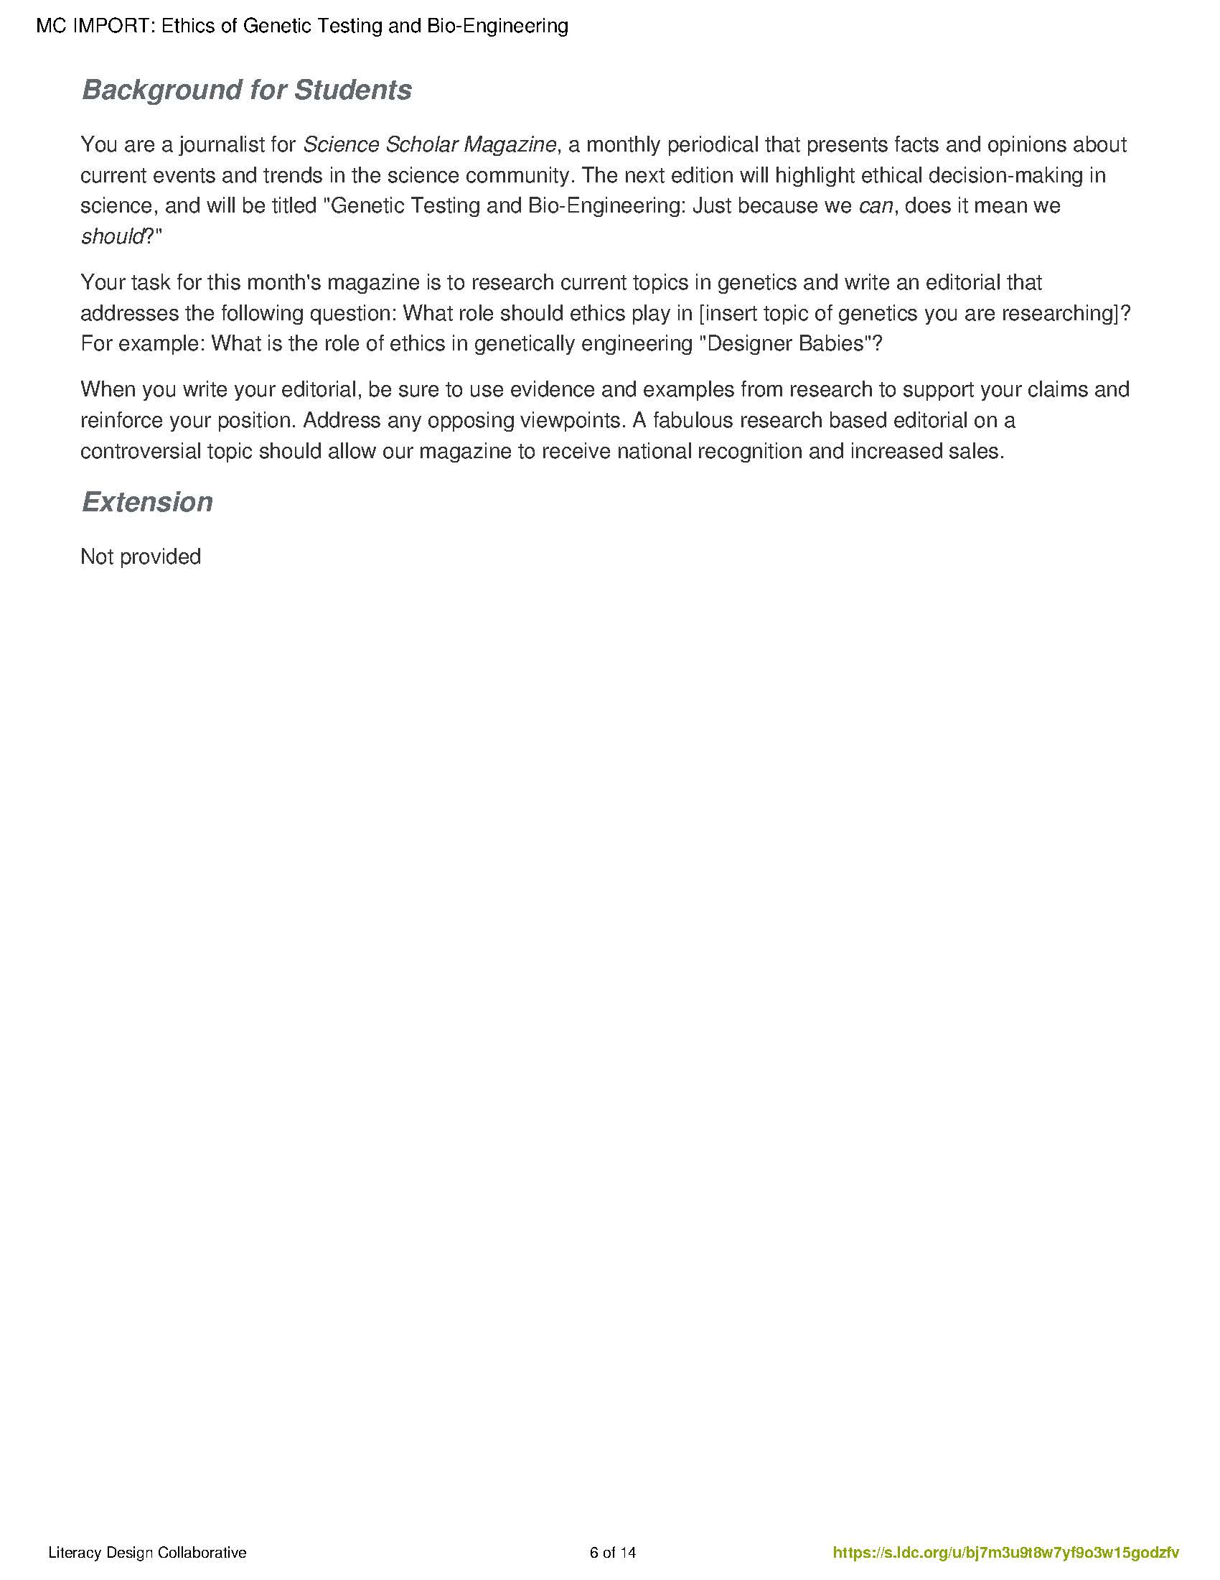

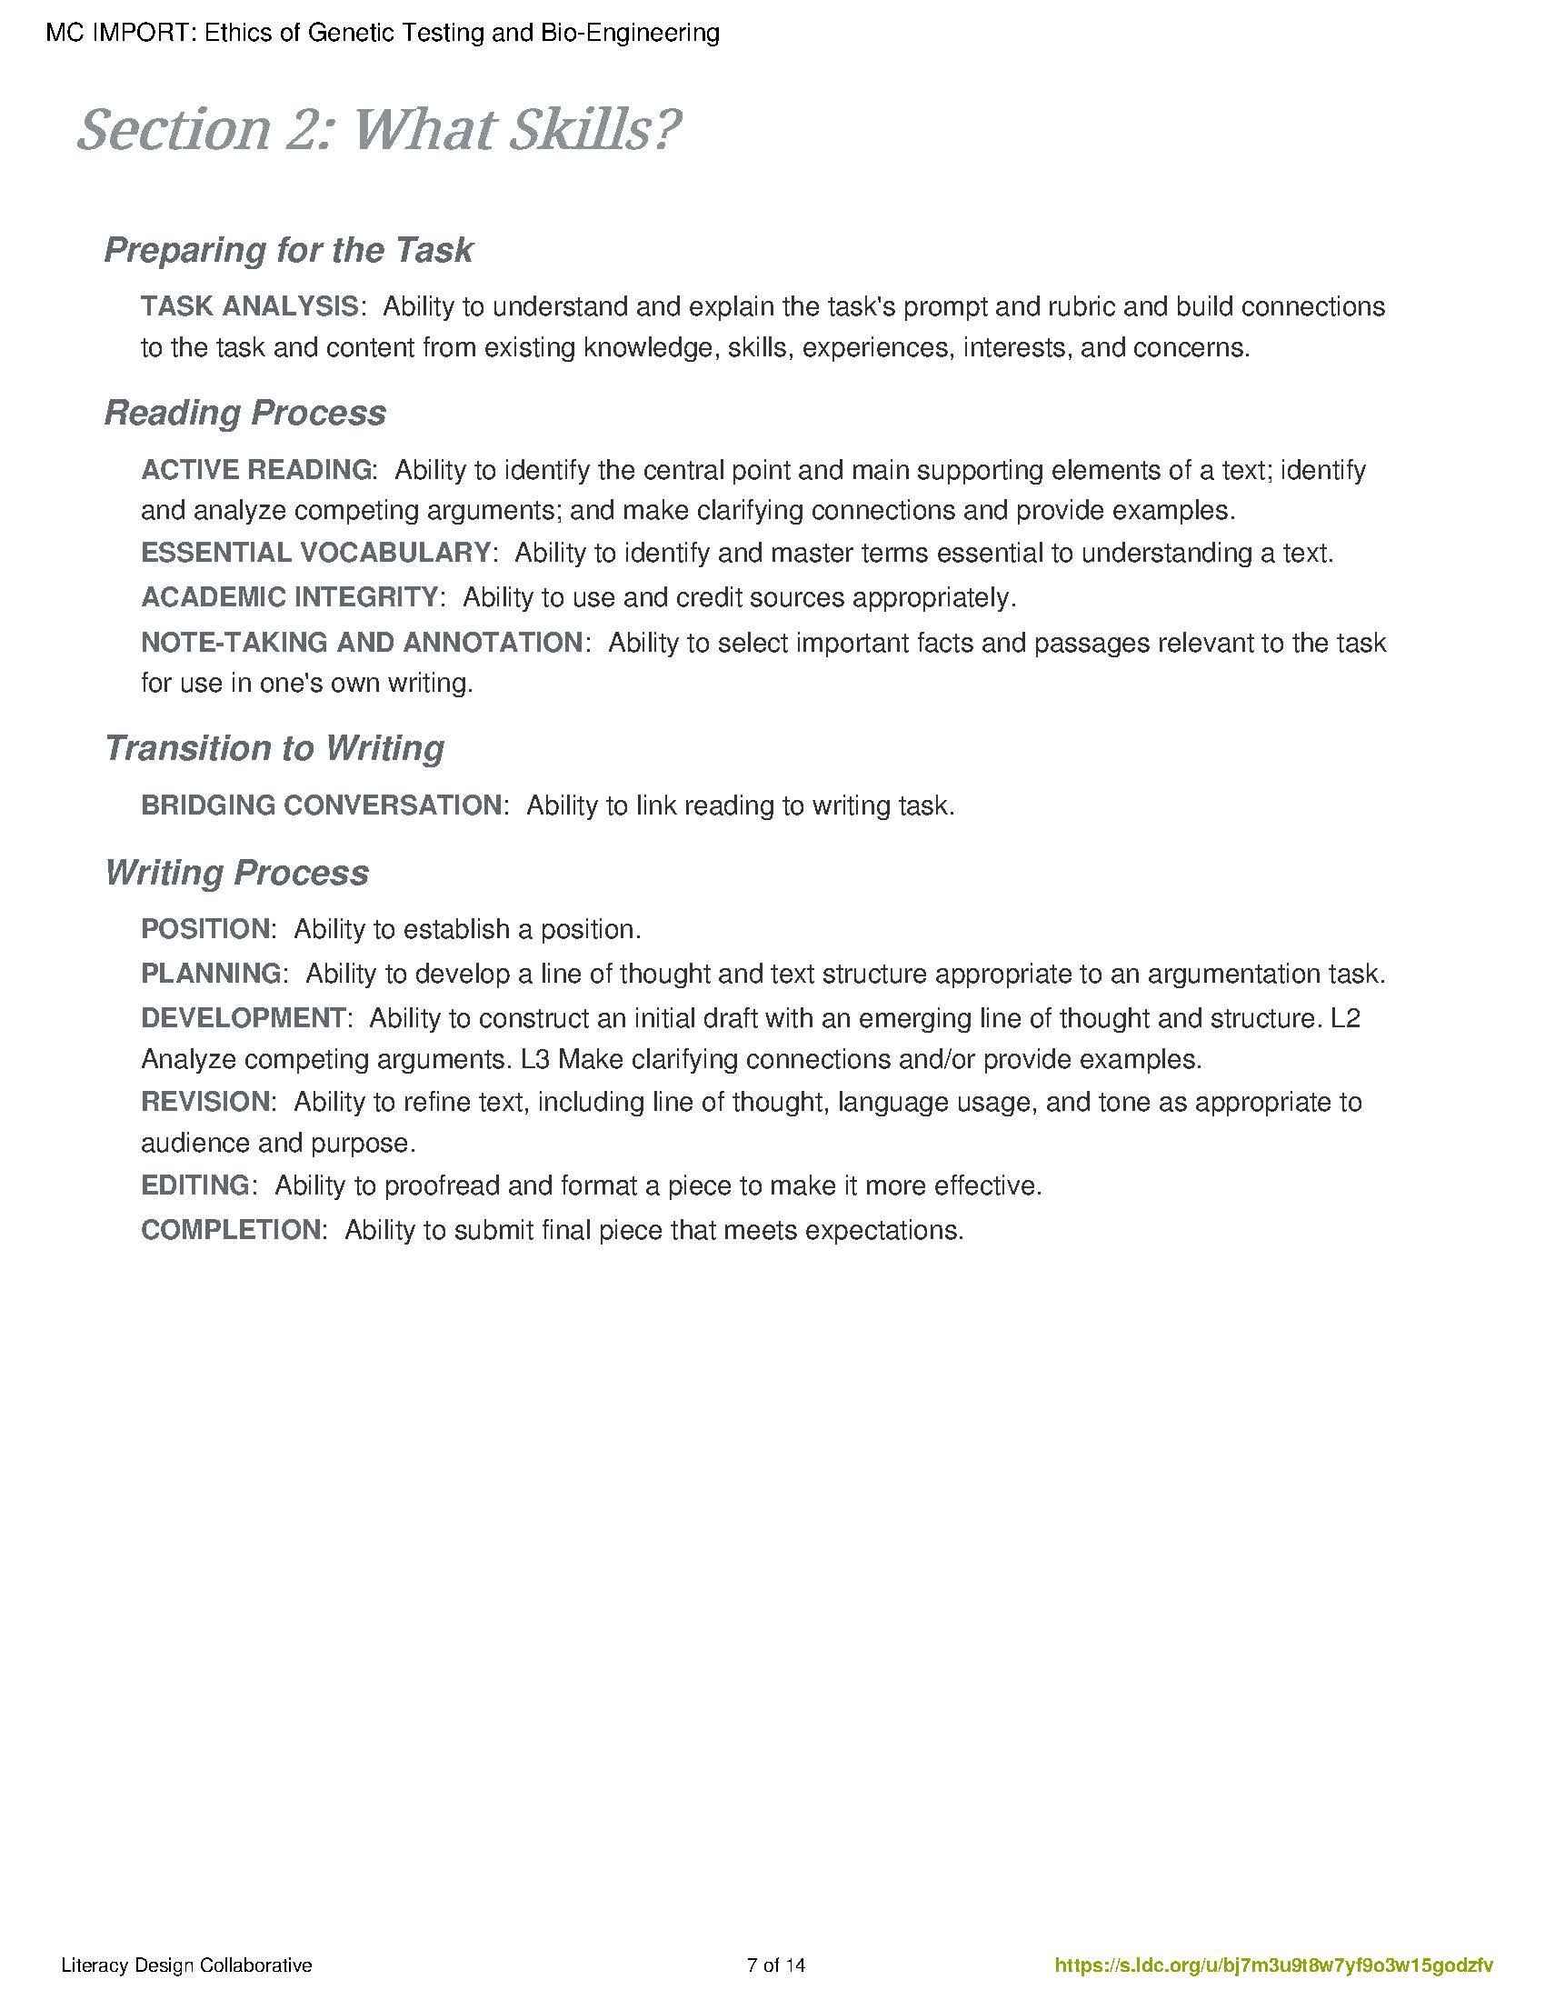

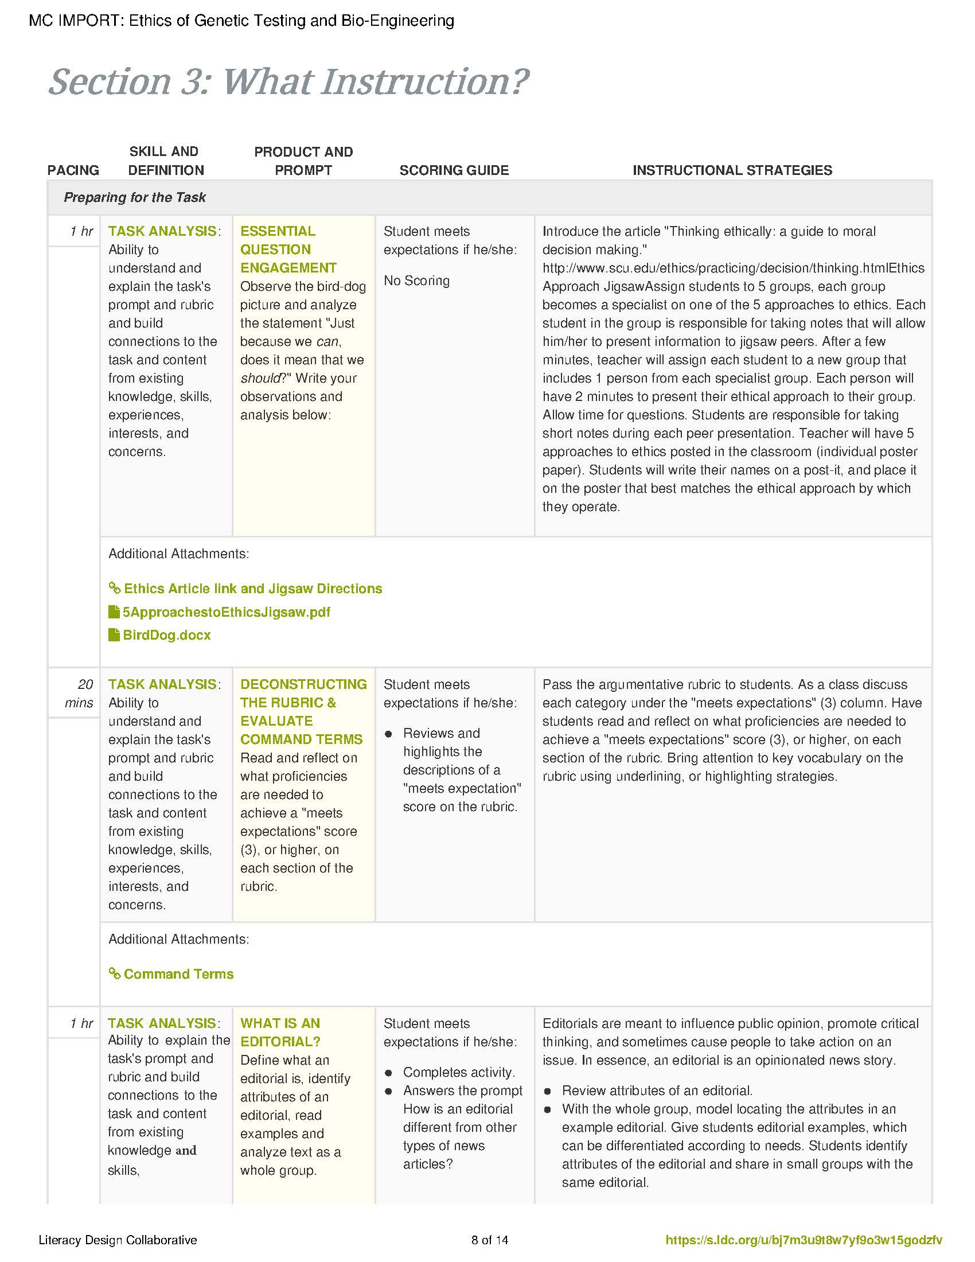

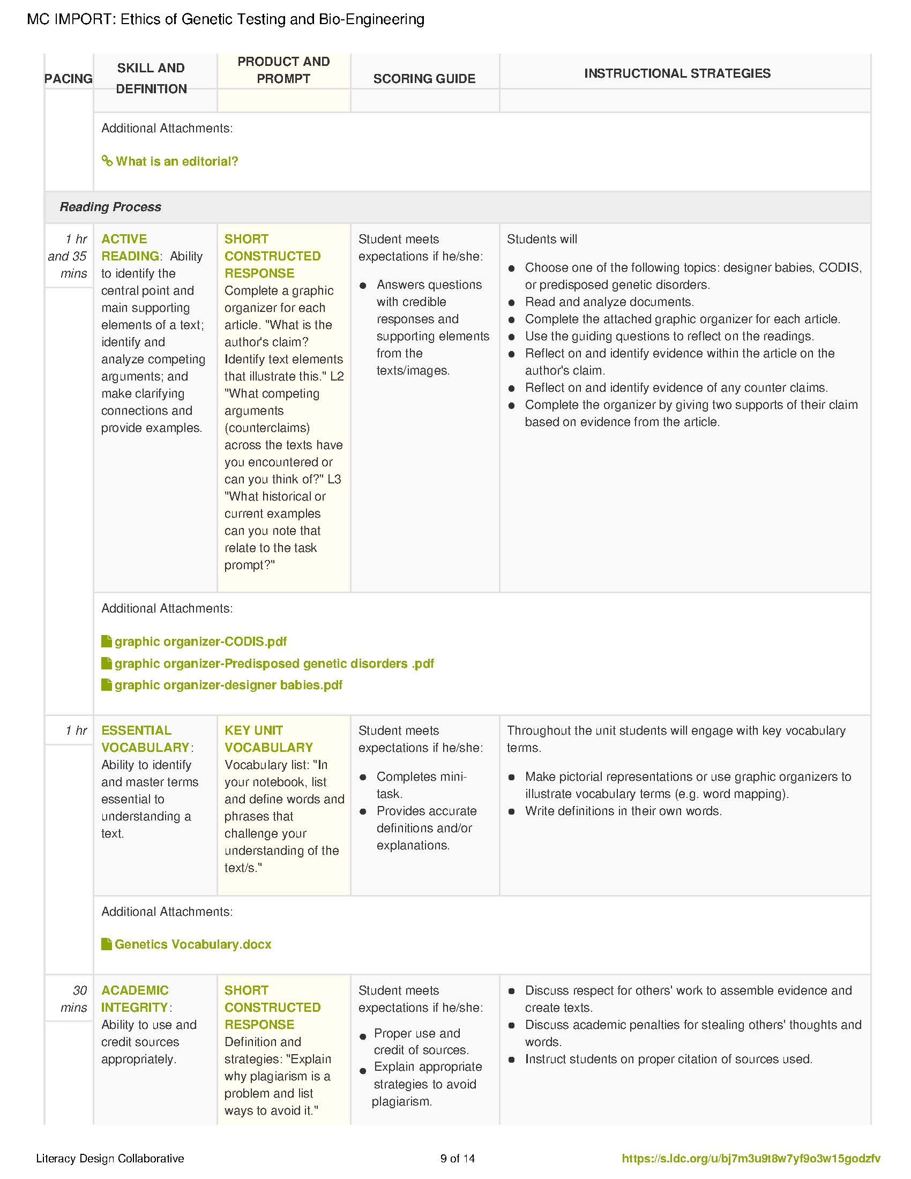

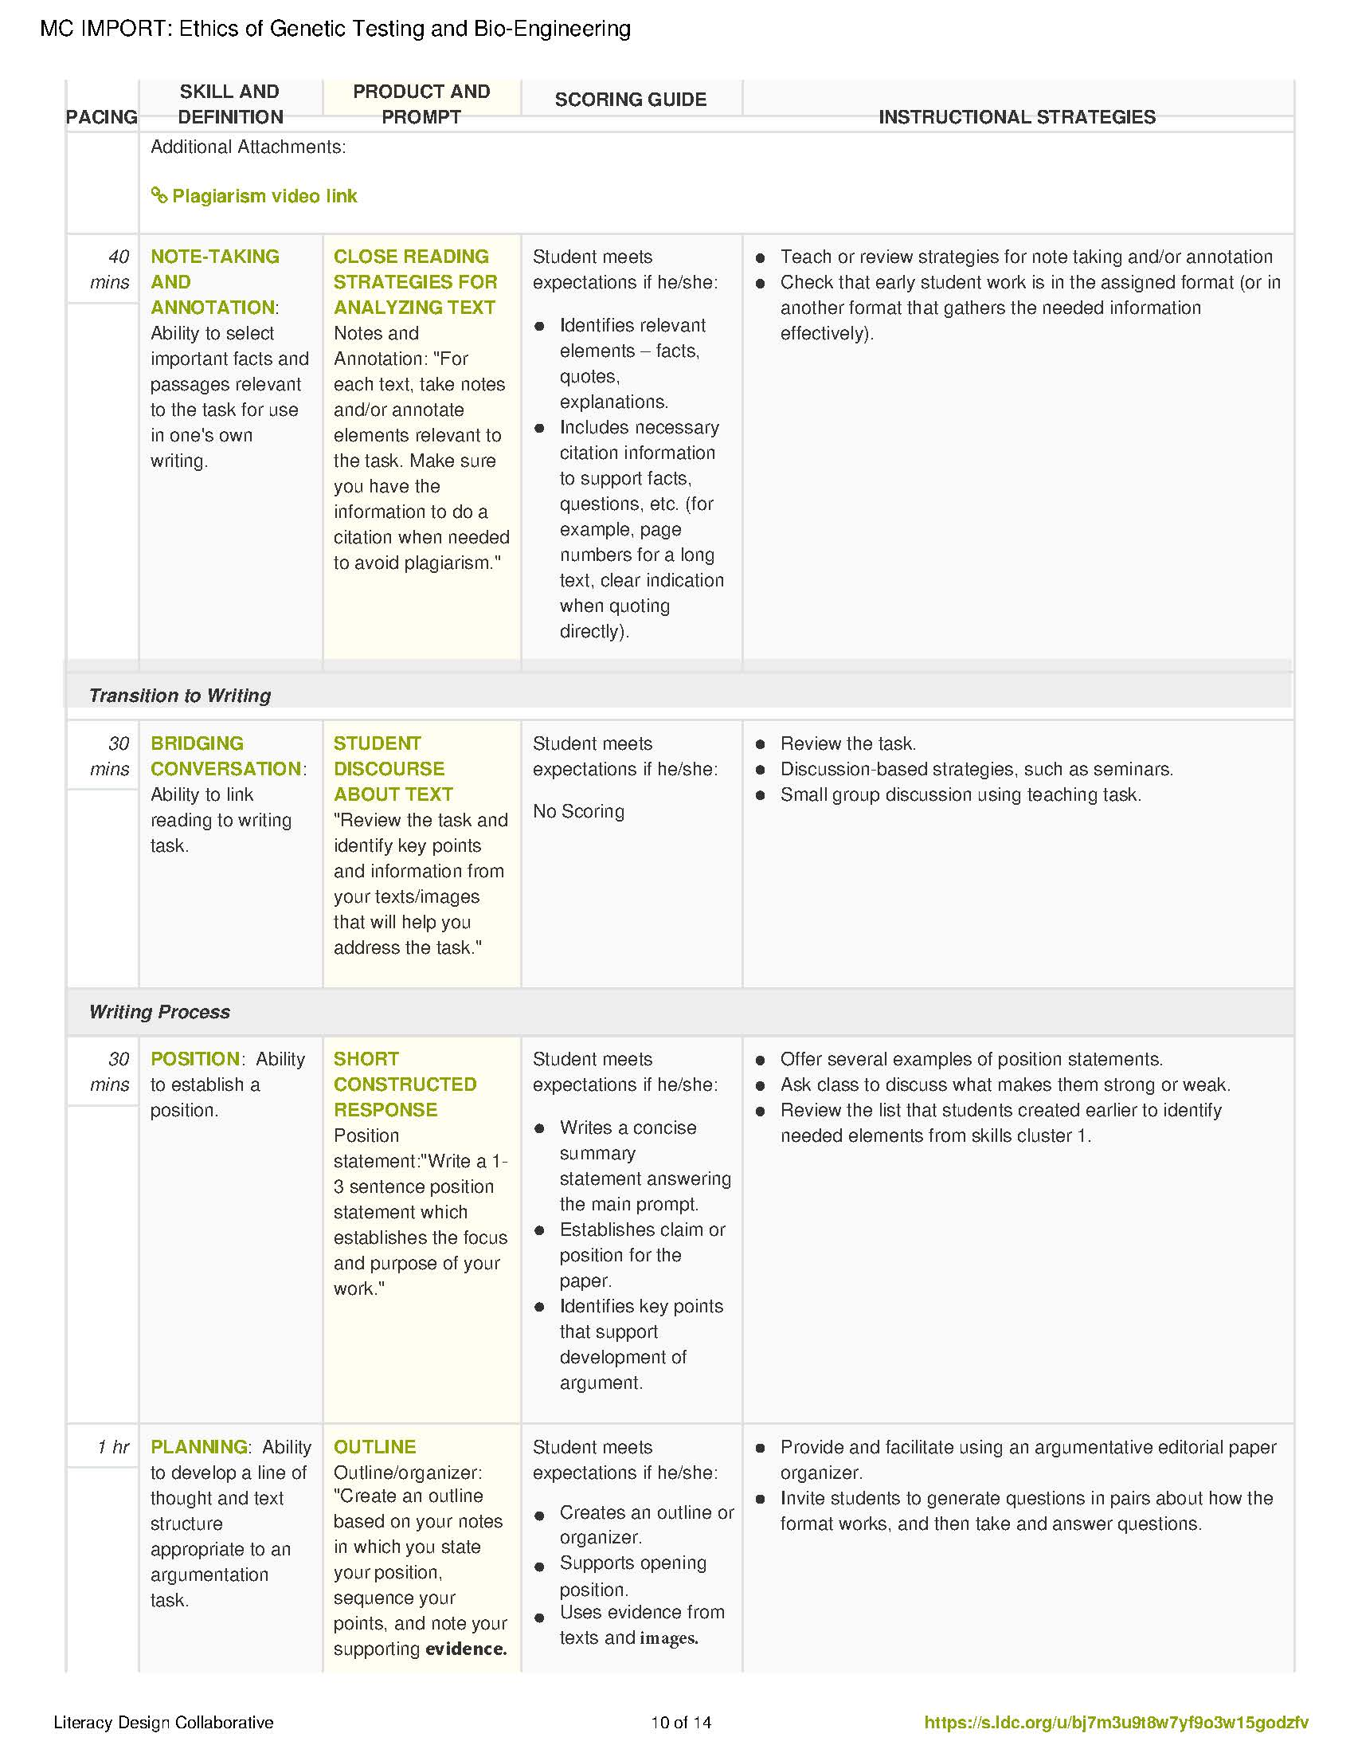

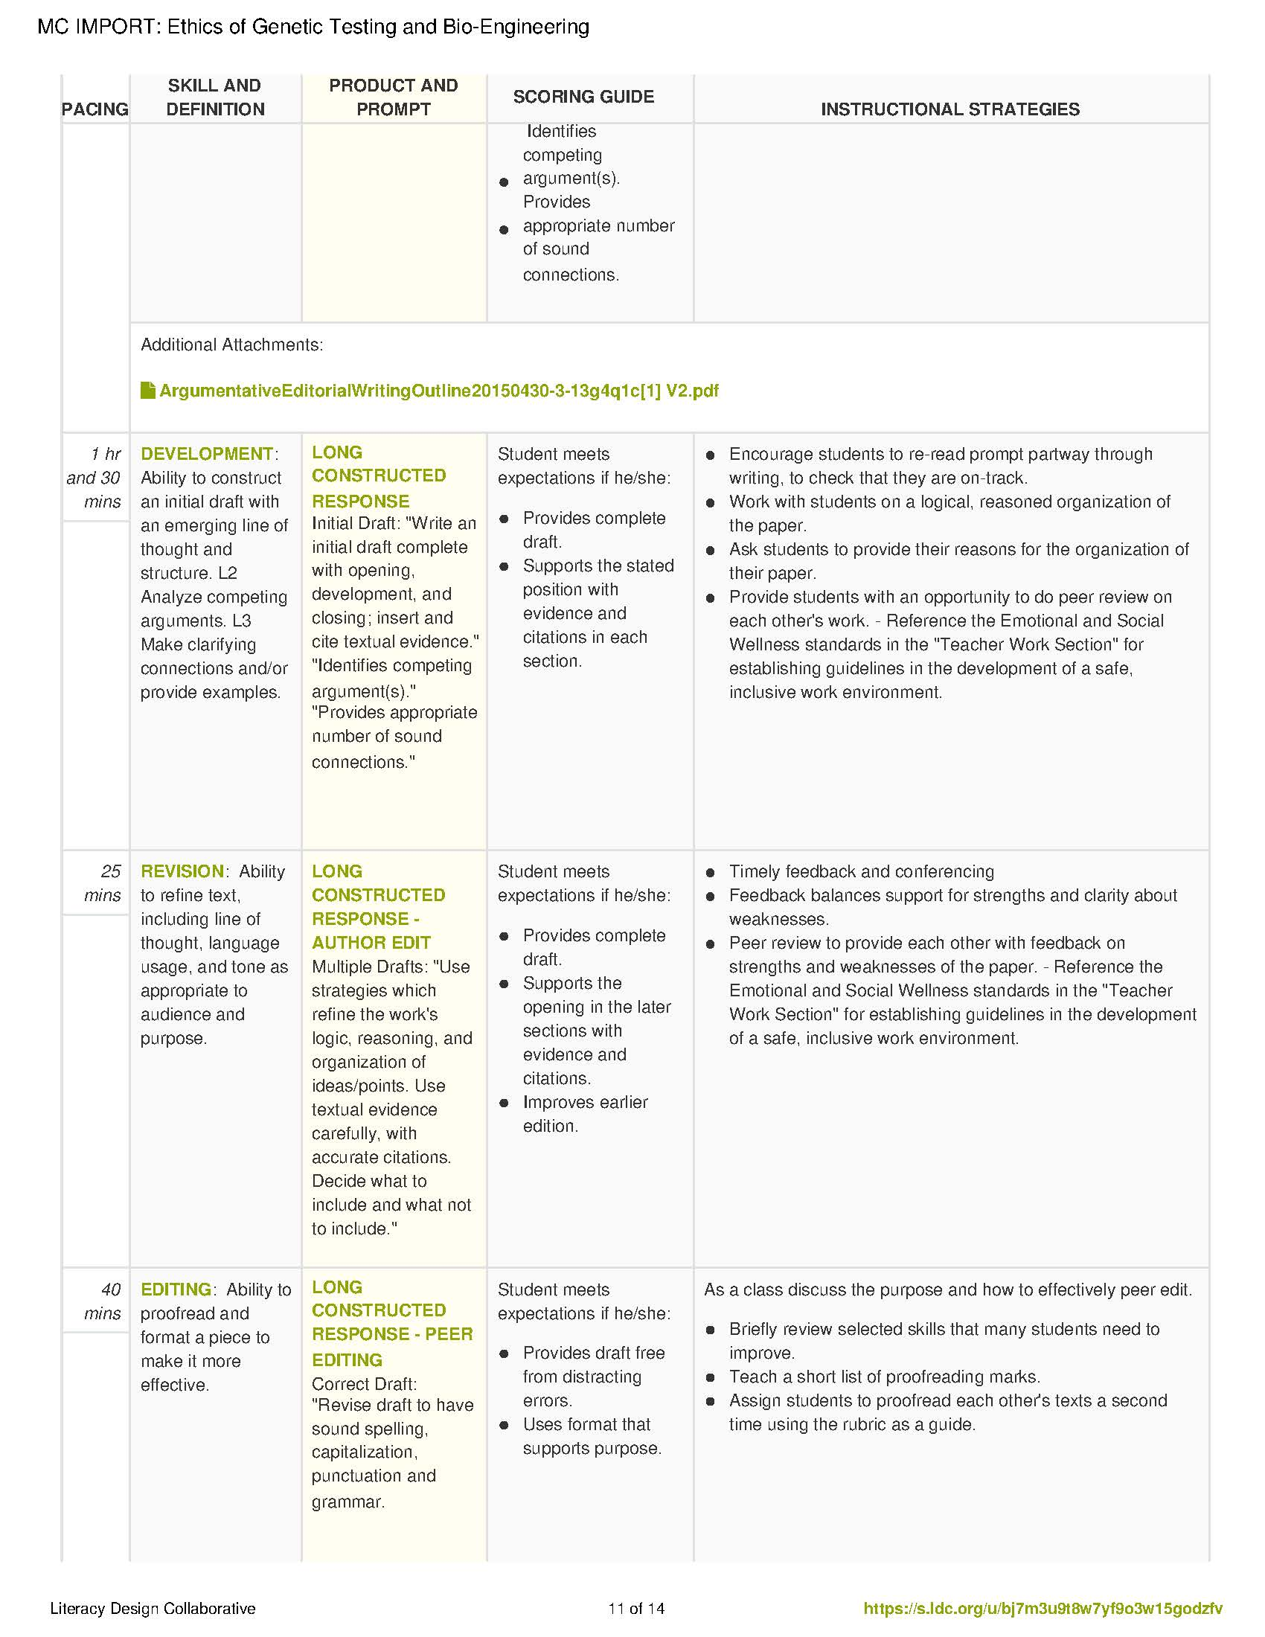

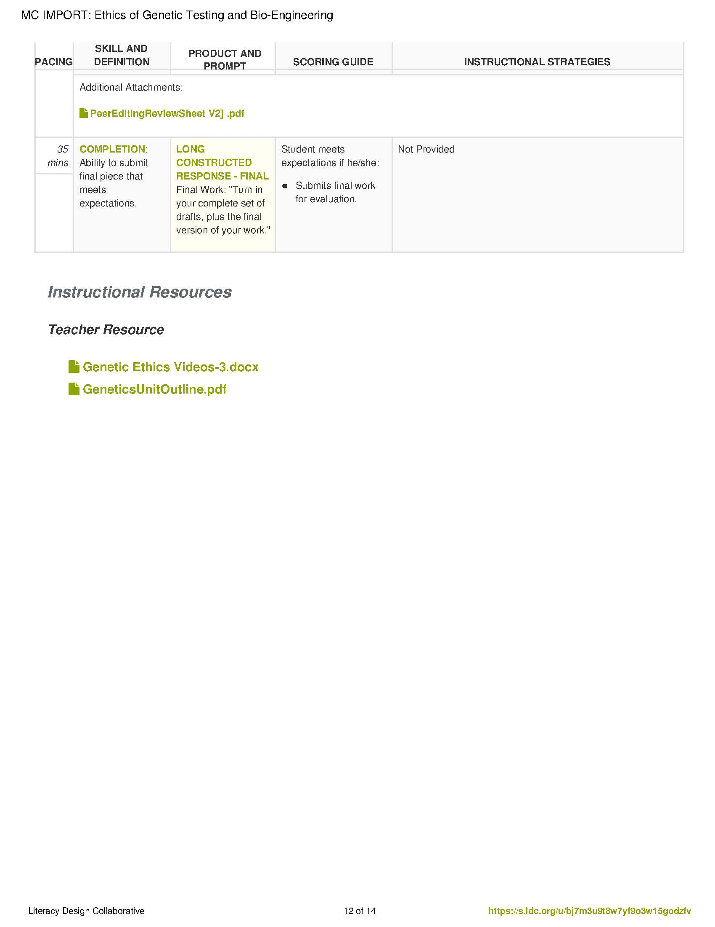

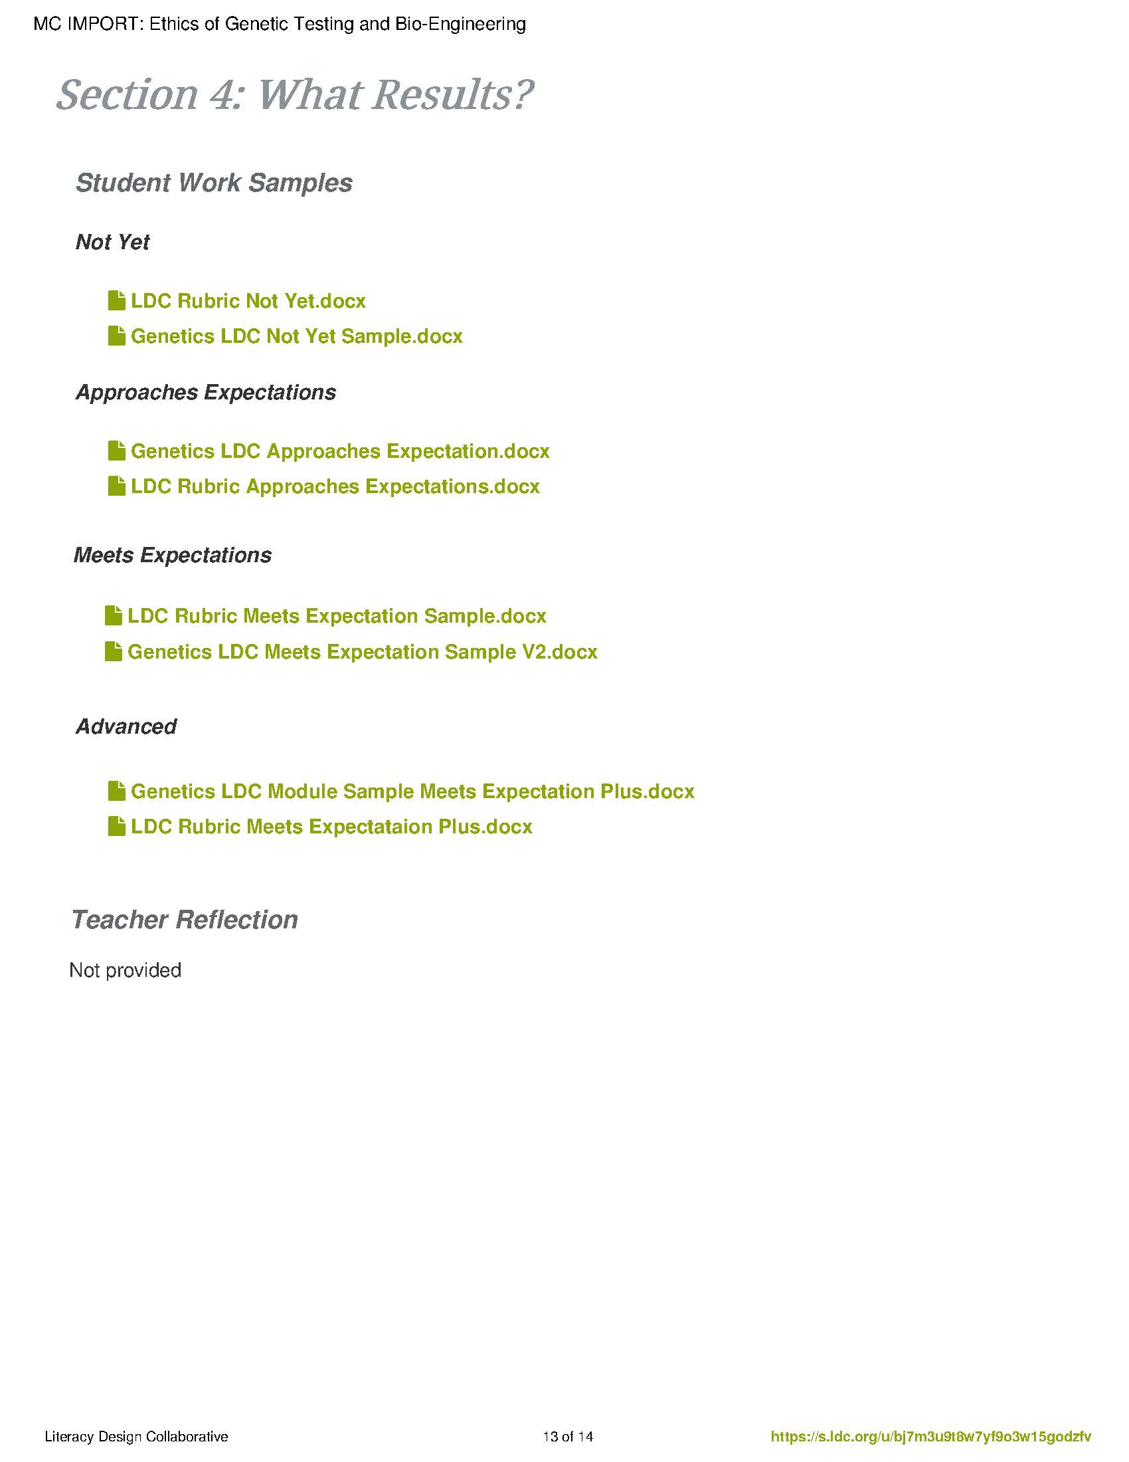

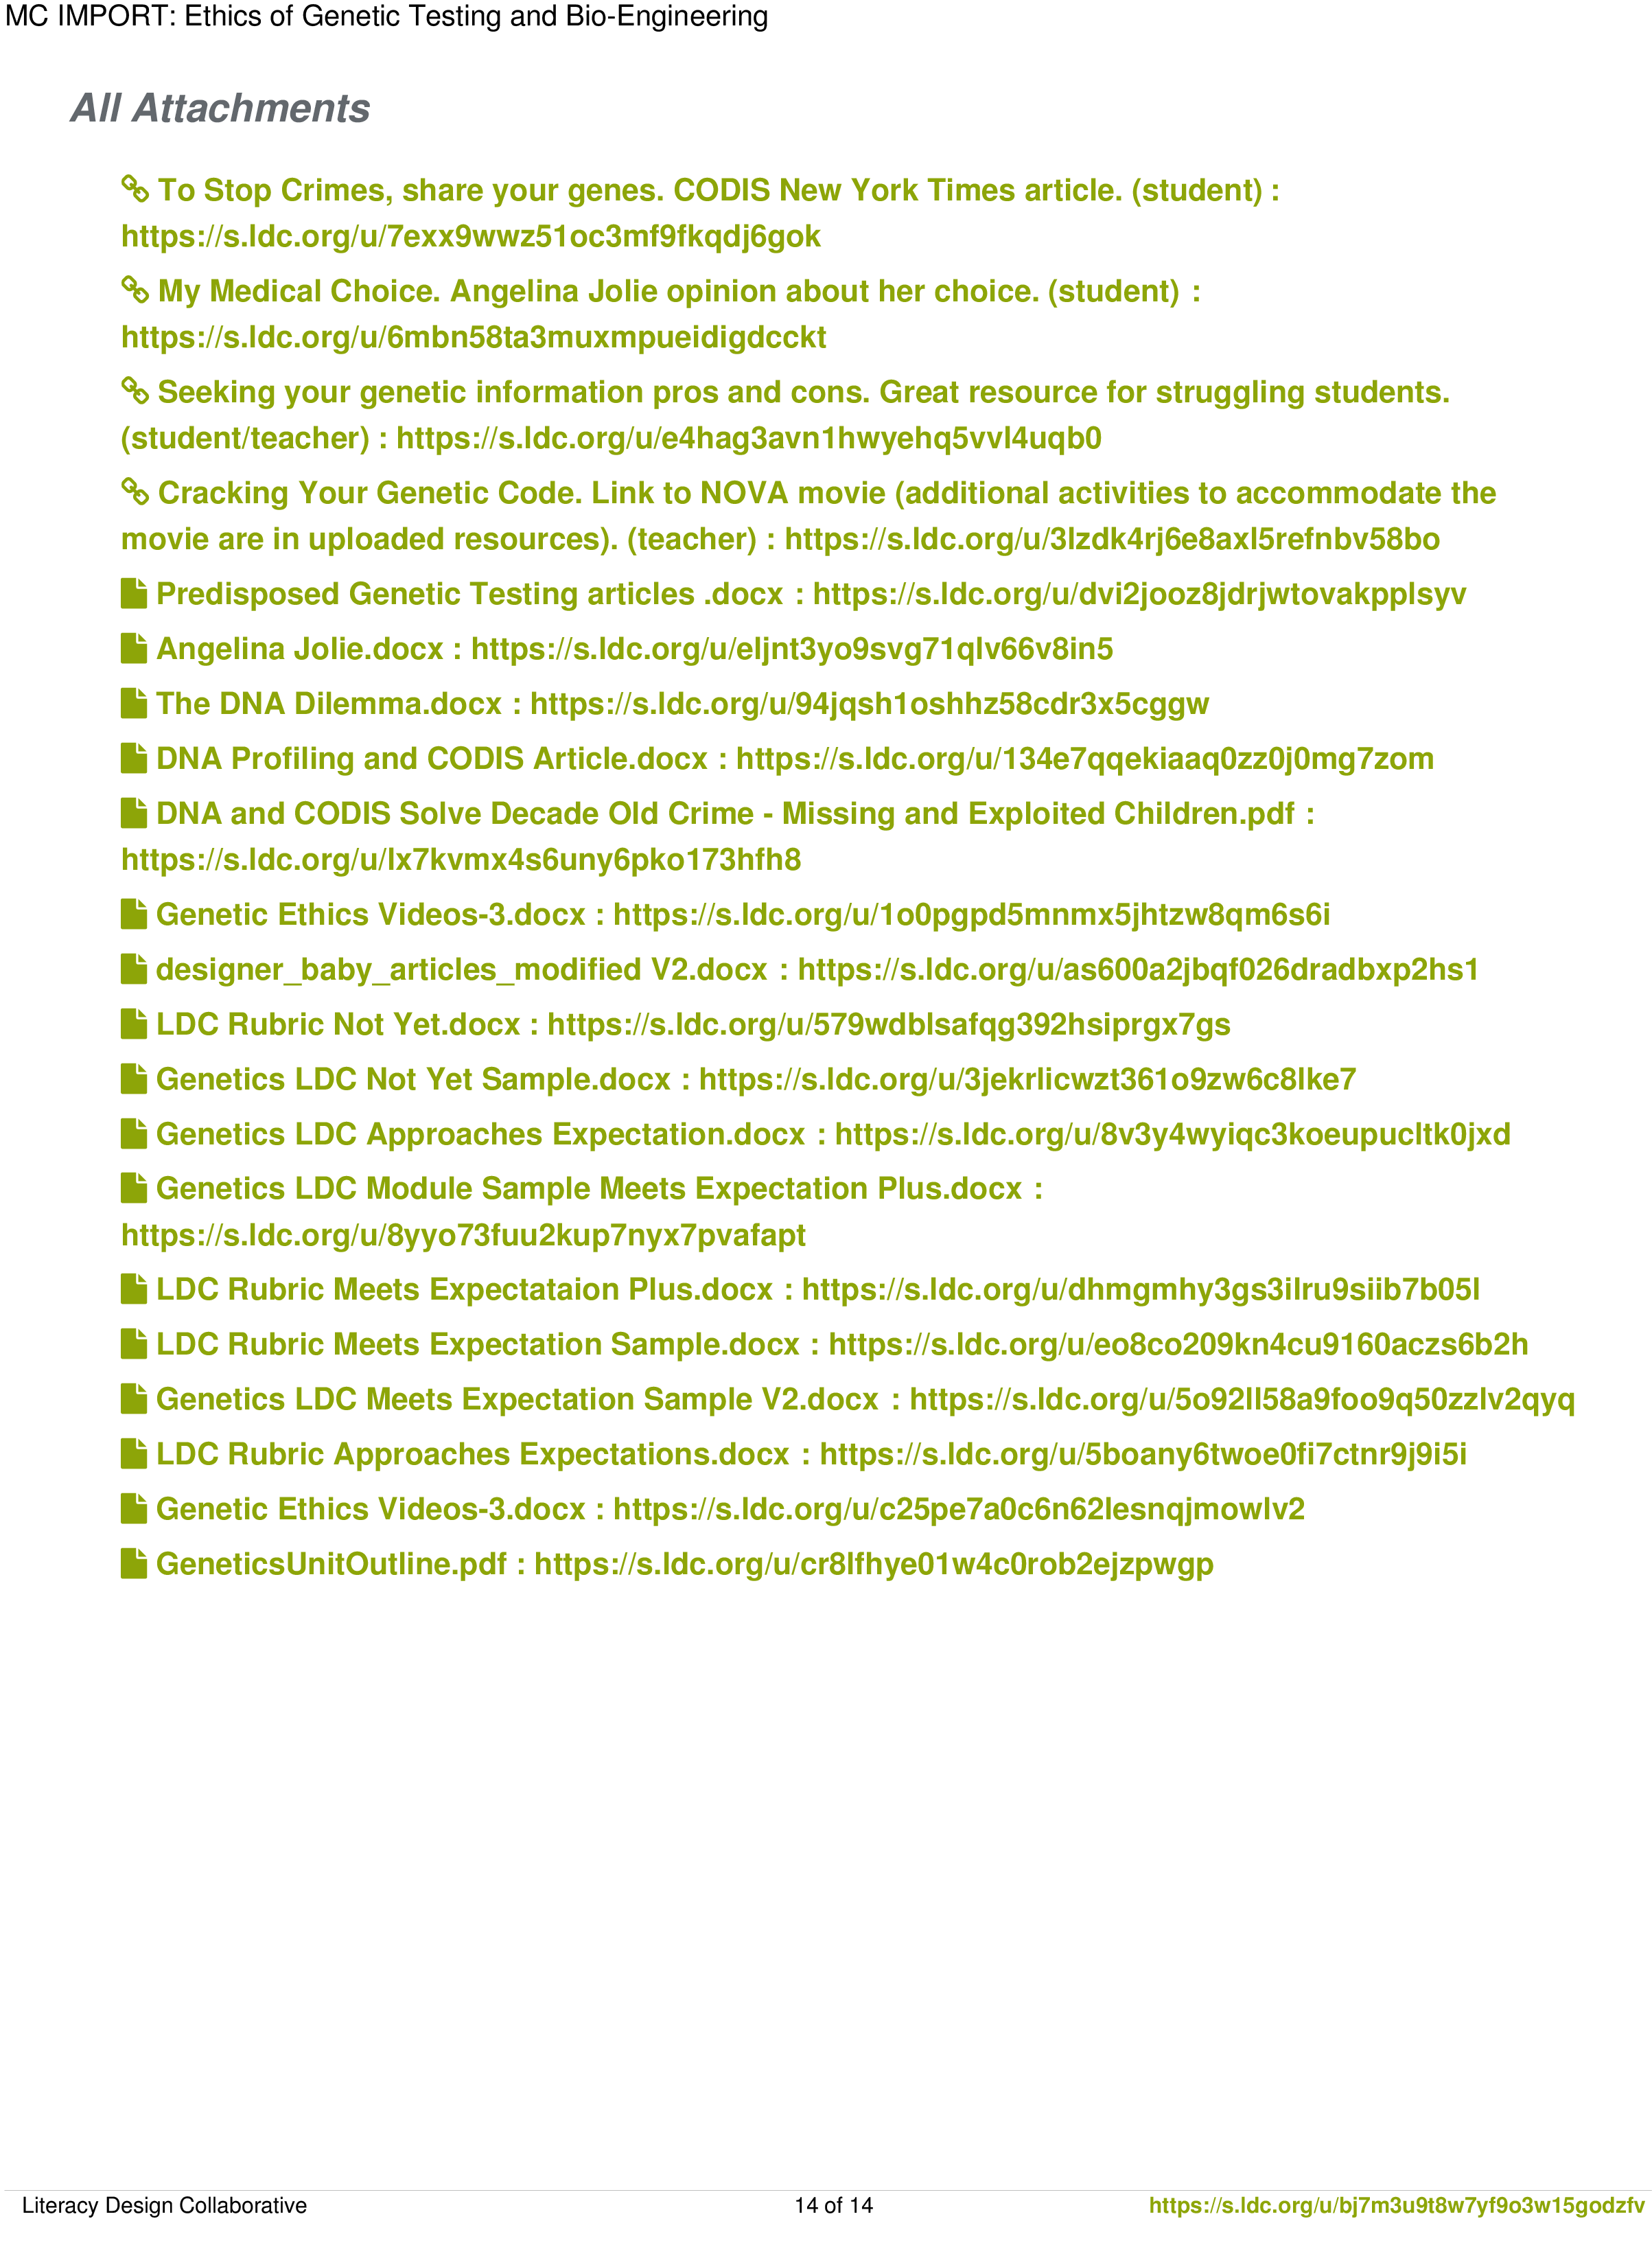

Modified LDC Rubric
SCORING DOMAIN | NOT YET | E/D | APPROACHING EXPECTATIONS | D/P | MEETS EXPECTATIONS | P/A | ADVANCED
Focus | Attempts to address prompt, but lacks focus or is off task. |  | Addresses prompt appropriately and establishes a position, but focus is uneven. |  | Addresses prompt appropriately and maintains a clear, steady focus. Provides a generally convincing position. |  | Addresses all aspects of prompt appropriately with a consistently strong focus and convincing position.
Reading/Research | Attempts to reference reading materials to develop response, but lacks connections or relevance to the purpose of the prompt. |  | Presents information from reading materials relevant to the purpose of the prompt with minor lapses in accuracy or completeness. |  | Accurately presents details from reading materials relevant to the purpose of the prompt to develop argument or claim. |  | Accurately and effectively presents important details from reading materials to develop argument or claim.
Development | Attempts to provide details in response to the prompt, but lacks sufficient development or relevance to the purpose of the prompt. (L3) Makes no connections or a connection that is irrelevant to argument or claim. |  | Presents appropriate details to support and develop the focus, controlling idea, or claim, with minor lapses in the reasoning, examples, or explanations. (L3) Makes a connection with a weak or unclear relationship to argument or claim. |  | Presents appropriate and sufficient details to support and develop the focus, controlling idea, or claim. (L3) Makes a relevant connection to clarify argument or claim. |  | Presents thorough and detailed information to effectively support and develop the focus, controlling idea, or claim. (L3) Makes (a) clarifying connection(s) that illuminates argument and adds depth to reasoning.
Content Understanding | Attempts to provide details in response to the prompt, but lacks sufficient development or relevance to the purpose of the prompt. (L3) Makes no connections or a connection that is irrelevant to argument or claim. |  | Presents appropriate details to support and develop the focus, controlling idea, or claim, with minor lapses in the reasoning, examples, or explanations. (L3) Makes a connection with a weak or unclear relationship to argument or claim. |  | Presents appropriate and sufficient details to support and develop the focus, controlling idea, or claim. (L3) Makes a relevant connection to clarify argument or claim. |  | Presents thorough and detailed information to effectively support and develop the focus, controlling idea, or claim. (L3) Makes (a) clarifying connection(s) that illuminates argument and adds depth to reasoning.

Genetic Testing and Bio-Engineering:
Just because we can, does it mean we should?
You are a journalist for Science Scholar Magazine, a monthly periodical that presents facts and opinions about current events and trends in the science community. The next edition will highlight ethical decision-making in science and will be titled “Genetic Testing and Bio-Engineering: Just because we can, does it mean we should?”
Your task for this month’s magazine is to research current events and opinions in genetics and write an editorial that addresses the following question: What role should ethics play in [insert field of science you are researching]? For example: What is the role of ethics in genetically engineering “Designer Babies”?
When you write your editorial, be sure to use evidence and examples from research to back up your claims and reinforce your position. Address any opposing viewpoints. A fabulous research-based editorial on a controversial topic should allow our magazine to receive national recognition and increased money in magazine sales.
The Prompt for the Editorial
L1: What role should ethics play in genetic testing or bio-engineering? After reading informational texts addressing a selected topic, write an editorial that addresses the question and support your position with evidence from the text(s). L2: Be sure to include and address competing viewpoints. L3: Give examples from past or current events or issues to illustrate and clarify your position.

