Summative Response Rubric
Score 4 | - You complete all parts of the question and communicate ideas clearly.  - You demonstrate in-depth understanding of the relevant concepts and ideas.  - Where appropriate, you offer insightful interpretations or extensions.  - You accurately use various content vocabulary.
Score 3 | - You complete most parts of the question and communicate clearly.  - You demonstrate an understanding of major concepts even though you overlook or misunderstand some less important ideas or details.  - You accurately use content vocabulary.
Score 2 | - You complete some parts of the question and communicate those components clearly.  - You demonstrate that there are gaps in your conceptual understanding.  - You use little content vocabulary.
Score 1 | - You show minimal understanding of the question.  - You address only a small portion of the question.  - You use no content vocabulary.
Score 0 | - Your answer is totally incorrect or irrelevant.

Moving West Summative Response

During the first half of the 19th century, the United States expanded across the North American continent. Some of the territory was won by the United States through conflict, and some was won through compromise. Regardless of how the land was added to the United States, many groups were affected by this expansion.
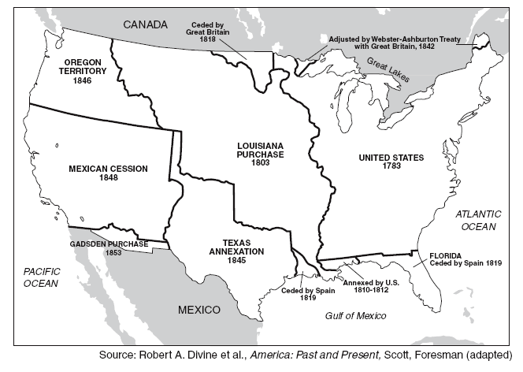

Write a well-developed response that addresses the following:
Part A: Explain, in detail, how the United States acquired two territories.
Part B: Choose two groups that were affected by westward expansion and describe the impact of expansion on these groups.

