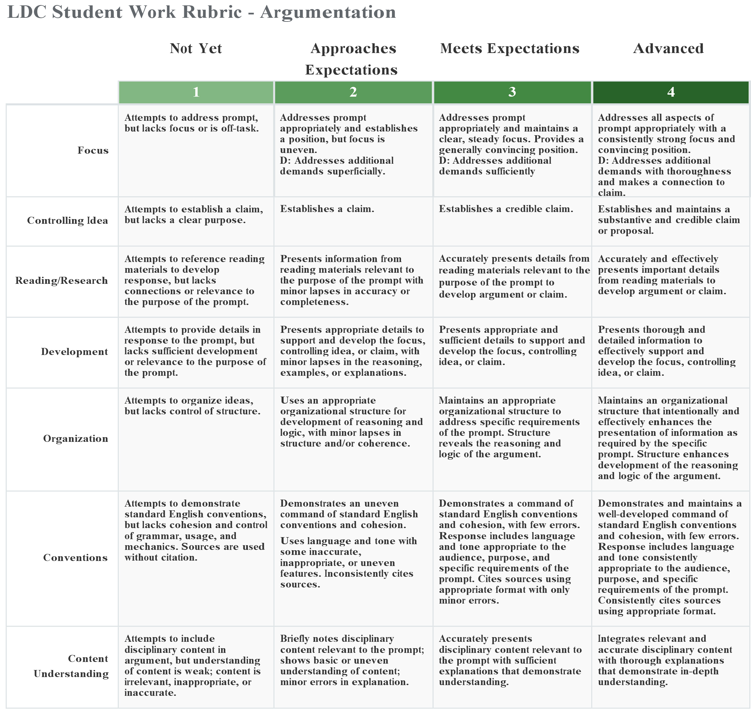

**Document 1: Polk’s Inaugural**

Source: *Excerpt from President James K. Polk’s inaugural address, March 5, 1845*

[E]ighty years ago our population was confined on the west by the ridge of the Alleghenies. Within that period . . . our people . . . have filled the eastern valley of the Mississippi, adventurously ascended the Missouri to its headsprings, and are already engaged in establishing the blessings of self-government in valleys of which the rivers flow to the Pacific. The world beholds the peaceful triumphs of the industry of our emigrants. To us belongs the duty of protecting them adequately wherever they may be upon our soil.

**Document 2: Thoreau**

Source: *Excerpt from Henry David Thoreau’s book,* Civil Disobedience*. He wrote it in prison between 1846-1848 and it was originally published in 1849.*

… Witness the present Mexican war, the work of comparatively a few individuals using the standing government as their tool; for, in the outset, the people would not have consented to this measure …

… In other words, when a sixth of the population of a nation which has undertaken to be the refuge of liberty are slaves, and a whole country is unjustly overrun and conquered by a foreign army, and subjected to military law, I think that it is not too soon for honest men to rebel and revolutionize. What makes this duty the more urgent is the fact that the country so overrun is not our own, but ours is the invading army…

*Thoreau:* [*http://thoreau.eserver.org/civil1.html*](http://thoreau.eserver.org/civil1.html)

**Document 3: Polk’s Letter**

Source: *Excerpt from Letter from President James K. Polk to his agent in Mexico, John Slidell. November 10, 1845.*

I am extremely desirous to acquire California…. If unfortunately, you should fail to effect a satisfactory adjustment of the pending differences between the two countries…I will call on Congress to provide the proper remedies.

**Document 4: Polk’s Special Message (Modified)**

Source: *Excerpt from President James K. Polk, to the Congress of the United States: a special message calling for a declaration of war against Mexico, Washington D.C., May 11, 1846.*

Note: *President Polk attempted to end the disputes with Mexico through diplomacy. He sent a representative to Mexico, but the Mexican government refused to speak with the representative and bloodshed began. Both the U.S. and Mexico claimed land between the Nueces and Del Norte rivers and both saw the other military as invading their land.*

Mexico has repeatedly threatened to make war upon us, for the purpose of reconquering Texas. In the meantime, we have tried every effort at reconciliation. The cup of forbearance [restraint] has been exhausted, even before the recent information from the frontier of the Del Norte. But now, after repeated threats, Mexico has passed the boundary of the United States, has invaded our territory and shed American blood upon American soil. She has proclaimed that hostilities have commenced, and that the two nations are now at war.. . .

We are called upon, by every consideration of duty and patriotism, to defend the honor, the rights, and the interests of our country.

**Document 5: Giddings (Modified)**

Source: *Excerpt from Congressman Joshua Giddings speech during the Debate on the Mexican War, House of Representatives, Washington D.C., May 13, 1846.*

Sir, no man regards this war as just. *We know*, the country knows, and the civilized worlds are conscious that it has resulted from a desire to extend and sustain an institution on which the Almighty [does not approve]. Mexico has long since abolished slavery and purified herself from its crimes and its guilt. Slaves now find asylum in the southwest and it has therefore become necessary to extend our people into Mexico in order to render slavery secure.. . .

This war is waged against an unoffending people, without just or adequate cause, for the purpose of conquest, with the design to extend slavery; in violation of the Constitution, against the dictates of justice, of humanity and the sentiments of the age in which we live and the [beliefs] of the religion we profess. I will not aid, no support whatever. I will not bathe my hands in the blood of the people of Mexico, nor will I participate in the guilt of those murders which have been and which will [later] be committed by our army there. For these reasons, I shall vote against the bill under consideration and all others calculated to support this war.

**Document 6: Sumner**

Source: *Excerpt from a speech Representative Charles Sumner delivered about the Mexican War at Tremont Temple in Boston, MA, on November 5, 1846.*

The Mexican War is an enormity born of slavery. Base in object, atrocious in beginning, immoral in all its influences, vainly prodigal of treasure and life, it is a war of infamy, which must blot the pages of our history.

**Glossary**

* Enormity: outrageous evil, wickedness
* Base: dishonorable, low
* Atrocious: extremely, shockingly wicked, cruel, or brutal
* Prodigal: wasteful
* Infamy: fame or being well known for a bad thing

**Document 7: Historian Haynes**

Source: *Excerpt from “Manifest Destiny” written by Historian Sam W. Haynes for PBS.org’s series, “U.S.-Mexican War” in 2006.*

Expansionists were also motivated by more immediate, practical considerations. Southerners anxious to enlarge the slave empire were among the most ardent champions of the crusade for more territory. New slave states would enhance the South’s political power in Washington and, equally important, serve as an outlet for its growing slave population. For American commercial interests, expansion offered greater access to lucrative foreign markets. Washington policy-makers, anxious to compete with Great Britain for the Asia trade, had long been convinced of the strategic and commercial advantages of San Francisco and other ports on the Pacific coastline of Mexican-owned California. The disastrous Panic of 1837, which had resulted in huge surpluses and depressed prices for American farm products, also focused attention on the need to develop new foreign markets.

Haynes: <http://www.pbs.org/kera/usmexicanwar/prelude/md_manifest_destiny.html> 

**Mexican War LDC Documents 1–7   
Comprehension Reading Questions**

**Document 1: Polk’s Inaugural**

1. What movement is Polk referring to in the first two sentences?
2. Why does Polk use the term “emigrant” instead of “immigrant”?
3. What have “our people” brought to the West?
4. What duty belongs to the United States?

**Document 2: Thoreau**

1. What “nation” is Thoreau referring to when he says, “a sixth of the population of this nation”?
2. Which country is Thoreau referring to when he says, “a whole country is unjustly overrun”?
3. Which foreign army is Thoreau referring to when he says, “conquered by a foreign army”?

**Document 3: Polk’s Letter**

1. What does Polk mean by “extremely desirous”?
2. What two countries is Polk talking about?
3. What pending differences is Polk referring to?
4. What could Polk mean by calling on Congress to “provide the proper remedies”?

**Document 4: Polk’s Special Message**

1. Why is Polk concerned for the people living in the West?
2. According to Polk, what has Mexico done that the United States must respond to?

**Document 5: Giddings**

1. How does Giddings feel about slavery?
2. According to Giddings, what are the reasons for going to war with Mexico?

**Document 6: Sumner**

1. What is Sumner’s view of the Mexican-American War?

**Document 7: Historian Haynes**

1. How is this source different from the other sources in this set?
2. What are three things that motivated Expansionists to support westward settlement?

Name:

**Vocabulary Collection Tool**

|  |  |  |
| --- | --- | --- |
| **Vocabulary Term** | **Definition** | **Picture** |
|  |  |  |
|  |  |  |
|  |  |  |
|  |  |  |
|  |  |  |
|  |  |  |
|  |  |  |
|  |  |  |

Name:

**Should the United States have gone to war with Mexico?**

|  |  |  |  |
| --- | --- | --- | --- |
|  | **Who wrote it?**  1. Name of author  2. Month and year document was written  3. Audience for document | **What is this source’s point of view on western lands or the Mexican-American War?** | **Write one piece of evidence from the document (quote or information) that shows this point of view.** |
| **Document**  **1** |  |  |  |
| **Document 2** |  |  |  |
| **Document 3** |  |  |  |
| **Document 4** |  |  |  |
| **Document 5** |  |  |  |
| **Document 6** |  |  |  |
| **Document 7** |  |  |  |

|  |  |
| --- | --- |
| **Sources that support  the Mexican-American War** | **Sources that oppose  the Mexican-American War** |
|  |  |

Name:

**Introducing Quotes Practice**

**Directions:** Using the authors, publications, and quotes given, write a sentence in which you incorporate all pertinent information. Remember, you can introduce a quote at the beginning or the end of a sentence.

Instead of “said,” try:

|  |  |  |  |  |  |
| --- | --- | --- | --- | --- | --- |
| Explained | Described | Emphasized | Acknowledged | Agreed | Claimed |
| Stated | Proclaimed | Illustrated | Suggested | Argued | Announced |

**Example:**

Mr. Cosby, an 8th grade teacher, *Beaumont Gazette,* “Although I do enjoy reading about princesses and dragons, my favorite kinds of stories are mysteries.”

|  |
| --- |
| In the *Beaumont Gazette*, Mr. Cosby, an 8th grade teacher, explained, “Although I do enjoy reading about princesses and dragons, my favorite kinds of stories are mysteries.” |

1. Mrs. Owen, construction worker, letter to the editor of the *Herald Leader*, “Building a garage is not as easy as it looks. It takes a lot of math, determination, and teamwork.”
2. Mrs. Friedlander, gardening enthusiast, *Home and Gardens* *Magazine,* “Flowers bring a smile to everyone’s face. I can’t help but smile when I look out at my garden and see my hard work blooming.”
3. Mr. Goff, World Fit leader, in an email to parents, “World Fit has been a great addition to our school. Our students are able to have a movement break and exercise, which improves their academics and behavior.”
4. Ms. Nelson, dog lover, Horse and Hound Online, “I believe everyone should own at least two dogs. They bring joy to every family, and I think we should make owning dogs a requirement in our country.”

Name:

**Mexican-American War LDC: Outline**

**First Body Paragraph: One reason for your side of the argument**

Topic sentence or claim:

Evidence (information and/or quotes):

Explanation of how evidence supports your argument:

**Second Body Paragraph: Second reason for your side of the argument**

Topic sentence or claim:

Evidence (information and/or quotes):

Explanation of how evidence supports your argument:

**Third Body Paragraph: Opposing argument**

Topic sentence or claim:

Explanation of opposing argument:

Evidence that supports opposing argument:

Reason and explanation detailing why your argument is stronger than this opposing argument:

**Introduction and Conclusion Organizers**

Your introduction paragraph should include a hook, background information necessary for your audience, and your thesis statement.

|  |
| --- |
|  |
|  |
|  |
|  |
|  |
|  |
|  |
|  |
|  |
|  |
|  |

Your conclusion paragraph should slightly mirror your intro paragraph. Start with a transition into a conclusion of your essay. Readdress or summarize key aspects of your essay for your audience.

|  |
| --- |
|  |
|  |
|  |
|  |
|  |
|  |
|  |
|  |
|  |
|  |
|  |

**Writer’s Checklist: LDC**

|  |  |  |
| --- | --- | --- |
| **Element** | **Your Own Check** | **Partner Check** |
| Does the introductory paragraph include necessary background information? |  |  |
| In your thesis statement, do you clearly state your view of Polk’s justification for going to war with Mexico? |  |  |
| Does each paragraph begin with a topic sentence or claim? |  |  |
| Is each reason developed so that the reader has a clear understanding of your ideas? |  |  |
| Are specific details and quotations included? |  |  |
| Do you explain how details and quotations support your argument? |  |  |
| When using quotes, are the sources of those quotes identified? |  |  |
| Do you include a counterclaim or contrary view? |  |  |
| Does the conclusion mirror the introduction and restate key points of your essay? |  |  |
| Does the paper use correct grammar and punctuation? |  |  |
| Does the paper flow—does it seem organized? |  |  |
| Give this paper a score: 1–5 (5 being the best) |  |  |

1. Give your partner two compliments about his or her paper. What were areas of strength?
2. Write at least one helpful comment. What can be changed in the essay to strengthen the argument?

**Writer’s Checklist: LDC**

|  |  |  |
| --- | --- | --- |
| **Element** | **Your Own Check** | **Partner Check** |
| Does the introductory paragraph include necessary background information? |  |  |
| In your thesis statement, do you clearly state your view of Polk’s justification for going to war with Mexico? |  |  |
| Does each paragraph begin with a topic sentence or claim? |  |  |
| Is each reason developed so that the reader has a clear understanding of your ideas? |  |  |
| Are specific details and quotations included? |  |  |
| Do you explain how details and quotations support your argument? |  |  |
| When using quotes, are the sources of those quotes identified? |  |  |
| Do you include a counterclaim or contrary view? |  |  |
| Does the conclusion mirror the introduction and restate key points of your essay? |  |  |
| Does the paper use correct grammar and punctuation? |  |  |
| Does the paper flow—does it seem organized? |  |  |
| Give this paper a score: 1–5 (5 being the best) |  |  |

1. Give your partner two compliments about his or her paper. What were areas of strength?
2. Write at least one helpful comment. What can be changed in the essay to strengthen the argument?