|  |  |  |
| --- | --- | --- |
| How and Why Did the U.S. Expand Westward?  The 1830s and 1840s | **U.S. History** | **Middle School** |
| **Common Assignment 1** | | |
| **Texas Independence and  Annexation Constructed Responses** | | |
| Table of Contents   1. Teacher Materials    1. Texas Independence PowerPoint    2. Key for Texas Independence Timeline    3. Texas Independence and Annexation Lesson Plan 2. Common Assessment Constructed Response Rubric 3. Student Materials    1. Texas Independence Timeline    2. Additional Documents for Texas Independence Lesson       1. [Document A: Texas Declaration of Independence](https://sheg.stanford.edu/texas-independence)       2. [Document B: Letter by Manchola](https://sheg.stanford.edu/texas-independence)       3. [Document C: Colonel Seguin’s Burial Speech](https://sheg.stanford.edu/texas-independence)       4. [Document D: Lundy’s Pamphlet](https://sheg.stanford.edu/texas-independence)       5. Document E: John Quincy Adams       6. Document F: Joint Resolution of Congress to Annex Texas    3. Texas Annexation Graphic Organizer    4. Texas Independence and Annexation Questions    5. Document for Further Study and Learning—Travis’ Letter | | |

Texas Independence PowerPoint

Use this PowerPoint to walk students through territorial expansion. Students fill out their own “Texas Independence Timeline” (included below) from the information in this PowerPoint presentation.

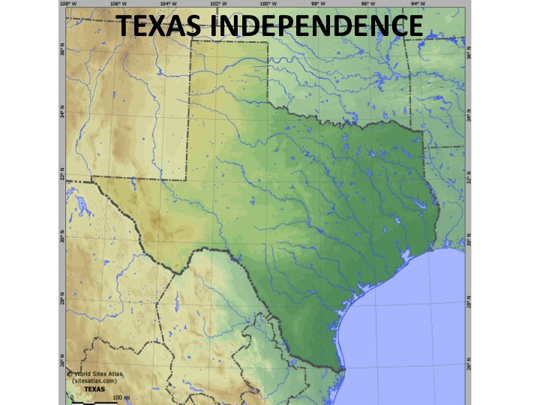

**Access the full PowerPoint here:** <http://collegeready.gatesfoundation.org/wp-content/uploads/2015/07/CAS-TEXAS-INDEPENDENCE-copy.ppt>

Key for Texas Independence Timeline

**1819**

**1822**

**1829**

**1836**

**1844**

**1837**

**1519–21**

**Conquistador Hernan Cortes conquers Aztec Empire (Mexico) for Spain.**

**Adams-Onis Treaty: U.S. acquires Florida from Spain.**

**Mexico gains its independence from Spain—Spain is no longer present in North America.**

**Stephen F. Austin settles 300 American families in Texas with permission from Mexico.**

**Settlers must obey Mexican laws and convert to Catholicism.**

**Mexico outlaws slavery.**

**Texas annexation defeated in Senate.**

**Texas declares independence.**

**Sam Houston defeats Santa Anna and wins Texas independence.**

**Outgoing President John Tyler signs a congressional joint resolution to annex Texas and make it part of the union. (Joint resolutions only require a simple majority vote instead of 2/3 majority.)**

**Abolitionists in the Senate block Texas annexation again—by one vote (the vote was 35-16, but 36 votes were needed).**

**1833**

**Santa Anna comes to power and throws out Mexico’s Constitution.**

**1830**

**Mexico bans Anglo immigration.**

**1821**

**1845**

**Santa Anna defeats Texans at Alamo.**

Texas Independence and Annexation Lesson Plan

Note: Use [the lesson](https://sheg.stanford.edu/texas-independence)  produced for the Stanford History Education Group’s (SHEG) Reading Like a Historian curriculum. Then modify and extend that lesson as is noted in this document.

First, download directions and documents for the SHEG plan at [https://sheg.stanford.edu/  
texas-independence](https://sheg.stanford.edu/texas-independence) . (You will need to create a free account.) Then read through that plan. Finally, see our modifications and extensions to that plan explained below. These additions extend the plan to include the annexation of Texas.

Modification: Substitute the United Streaming Video segment that is available only through subscription with:

* The History Channel’s “The Founding of Texas” Part 1 (a segment of “The Real West”) <http://www.youtube.com/watch?v=RA3smbU2b4k> 

and/or

* The History Channel’s “The Founding of Texas” Part 2 (a segment of “The Real West”) <http://www.youtube.com/watch?v=uFJIR0YYI2A> 

Extension: , tools, and instructional steps provided.

These are:

* Documents E and F
* Texas Annexation Graphic Organizer
* Additional instructional steps that follow Step 4 in the SHEG lesson

Additional Instructional Steps

Implement the SHEG lesson and then continue with the following instructional steps. Step 4—discussion questions—is the last step in the SHEG lesson, and the additional instructional steps follow.

1. Discussion questions

* Why did Texans declare independence?
* Were Texans justified in declaring independence?
* Were these honorable men, fighting for freedom or greedy slaveholders?
* What evidence from the documents supports your position?
* Which of these pieces of evidence do you find more/less trustworthy? Why?
* Why do historians still debate this question?

1. Hand out documents E and F. Students read documents and fill out Texas annexation graphic organizer.
2. Annexation discussion questions

* Once Texas declared and won its independence, is the United States free to annex it? Why would Mexico object to the American annexation of Texas?
* Why was Texas’ annexation denied twice before becoming a reality?

1. Students independently write answers to two constructed response questions.
2. Ideas for further study and learning

* Have students discuss the situation in the Alamo and write a letter to the people of Texas asking for helping in defending the Alamo and stopping or delaying Santa Anna’s army.
* Show students William Barret Travis’ primary source to compare to their letter.
* Show clips from two Hollywood movies of the Alamo where Travis’ letter is used.
* These two movies are John Wayne’s **"**The Alamo" and John Lee Hancock’s, "The Alamo," starring Billy Bob Thornton.
* Both movies use a version of Travis’ letter with reference to the underlined sentences. In John Wayne’s version, the Mexican army comes to the fort and reads a message from Santa Anna demanding surrender, and Travis uses his cigar to light a cannon in response to the demand. In the Billy Bob Thornton version, Jim Bowie is in a discussion with Mexican officers who are demanding surrender when Travis fires the cannon in his general direction.

**Common Assessment Constructed Response Rubric**

Why did Texans declare independence from Mexico in 1836? Use evidence from the texts to support your answer and explain your reasoning.

|  |  |
| --- | --- |
| **Score Point 2** | * You complete all components of the question and communicate ideas clearly. * Evidence (specific information or quotations from the document) is accurately explained to support a claim. |
| **Score Point 1** | * You provide a partially correct answer to the question and/or address only a portion of the question. * Evidence (specific information or quotations from documents) is included to support a claim but not explained. |
| **Score Point 0** | * Evidence is absent, inaccurate, or not relevant to the argument or prompt. |

**Common Assessment Constructed Response Rubric**

Texas declared and won its independence and applied for statehood. Using evidence from the texts and logical reasoning, why did Mexico and some Americans object to Texas annexation?

|  |  |
| --- | --- |
| **Score Point 2** | * You complete all components of the question and communicate ideas clearly. * Evidence (specific information or quotations from the document) is accurately explained to support a claim. |
| **Score Point 1** | * You provide a partially correct answer to the question and/or address only a portion of the question. * Evidence (specific information or quotations from documents) is included to support a claim but not explained. |
| **Score Point 0** | * Evidence is absent, inaccurate, or not relevant to the argument or prompt. |

**Texas Independence Timeline**

**1819**

**1822**

**1829**

**1836**

**1844**

**1837**

**1519–21**

**1833**

**1830**

**1821**

**1845**

**Document E: John Quincy Adams**

The treaty for the annexation of Texas to this Union was this day sent in to the Senate; and with it went the freedom of the human race.

Source: *Excerpt from John Quincy Adams, former president and Representative from Massachusetts, writing in his diary on April 22, 1844.*

**Document F: Joint Resolution of Congress to Annex Texas (Modified)**

Note: *This is an excerpt from a Resolution that was passed by the U.S. Congress on March 1, 1985. It approved the admission of Texas as a state to the United States. It also laid out the requirements of that admission. Below is one of those requirements.*

Joint Resolution for annexing [adding] Texas to the United States.

. . .

2. Be it further resolved, that the consent of Congress is given upon the following conditions, and with the following guarantees:. . .

New states, of convenient size, not exceeding four in number, in addition to the state of Texas, and having sufficient population, may hereafter, be formed out of the territory, which shall be entitled to admission under the provisions of the federal constitution. And such states as may be formed out of that portion of this territory lying south of thirty-six degrees thirty minutes north latitude, commonly known as the Missouri compromise line, shall be admitted into the Union with or without slavery, as the people of each state asking admission may desire. And in such state or states as shall be formed out of this territory north of said Missouri compromise line, slavery, or involuntary servitude, (except for crime,) shall be prohibited.

**Texas Annexation Graphic Organizer**

|  |  |  |  |
| --- | --- | --- | --- |
|  | **Who wrote it?**   1. Name of author/document 2. Mexican or American? 3. Year document was written | **What is the view of annexation represented by this document?** | **Provide a quote to support your answer.** |
| **Document E** |  |  |  |
| **Document F** |  |  |  |

Name:

**Texas Independence and Annexation**

**Directions:** Using the documents and completed graphic organizer (documents A, B, C, D), answer the following question using evidence from the text.

Why did Texans declare independence from Mexico in 1836? Use evidence from the texts to support your answer and explain your reasoning.

**Directions:** Use the documents and completed graphic organizer (documents D, E, F) to answer the following question using evidence from the text and logical reasoning.

Texas declared and won its independence and applied for statehood. Why would Mexico and some Americans object to Texas annexation?

**Document for Further Study and Learning—Travis’ Letter**

Commandancy of the Alamo  
Bexar, Fby. 24th, 1836

To the People of Texas & all Americans in the world

Fellow Citizens & Compatriots,

I am besieged by a thousand or more of the Mexicans under Santa Anna. I have sustained a continual bombardment & cannonade for 24 hours & have not lost a man. The enemy has demanded a surrender at discretion, otherwise the garrison are to be put to the sword if the fort is taken. I have answered the demand with a cannon shot, and our flag still waves proudly from the walls. I shall never surrender nor retreat.

Then, I call on you in the name of Liberty, of patriotism, & of everything dear to the American character, to come to our aid with all dispatch. The enemy is receiving reinforcements daily & will no doubt increase to three or four thousand in four or five days. If this call is neglected, I am determined to sustain myself as long as possible & die like a soldier who never forgets what is due to his own honor & that of his country.

Victory or Death   
William Barret Travis   
Lt. Col. Comdt.   
  
P. S. The Lord is on our side. When the enemy appeared in sight we had not three bushels of corn. We have since found in deserted houses 80 or 90 bushels & got into the walls 20 or 30 head of Beeves.   
  
Travis