What Caused McCarthyism? | U.S. History | High School
Common Assignment 3
LDC Module
Table of Contents
- Teacher Materials
  - Teacher Instructions
- LDC Argumentation Rubric (modified)
- Student Materials
  - LDC Instructions and Article Summary Sheet
  - LDC Documents
    - Excerpt from President Truman’s Executive Order 9835—Loyalty Order
    - Excerpt from McCarthy’s Wheeling Speech
    - Excerpt from J. Edgar Hoover speech before HUAC
    - Federal Civil Defense Administration film: Bert the Turtle
    - Excerpt from the Truman Doctrine
    - Two Herb Block Cartoons
  - Claim Creator and Evidence Analysis Tool
  - Essay Outline Assignment
    - Outlining: A Web Method
    - Essay Planner



Teacher Instructions
Performance Outcomes
Students will
- Construct and defend a written historical argument using evidence;
- Use textual evidence to support accurate analysis of primary sources;
- Integrate information from diverse sources;
- Recognize and identify a counterclaim; and
- Demonstrate understanding of multiple causation.
Note: An experiential activity should precede the sequence below. For example, see the Dot activity included in Introductory Activities: Setting Context.

Mini-Task 1: Task and Rubric Analysis
Students analyze the prompt and rubric to understand what is expected of them.
Mini-Task 2: Article Summaries
Introduce the students to the LDC documents, and ask students to analyze each document using an Article Summary Sheet.
Mini-Task 3: Seminar—Two Circle Discussion
Students talk about the texts in a structured discussion format to prepare for writing, hear multiple perspectives, and synthesize information and evidence.
- Assign all students their role for the discussion (half of the class will form an inner circle and the other half of the class the outer circle).
- Teacher facilitates inner circle discussion. Students in the inner circle discuss the prompting questions. These include:
  - How does this document help you answer the prompt?
  - What evidence supports your answer?
  - How does this document support, contest, or extend what you learned from another document?
- Students in the outer circle are to listen attentively to the discussion, but they may not speak. They should listen and take notes.
- After a set period of time, students in the outer circle may ask questions or elaborate on what the inner circle has said. No questions are to be addressed to any particular student. Instead, each student just asks his/her question, and it is up to the inner circle as a whole to answer it.
- Students switch roles and continue the discussion.
Mini-Task 4: Claim Creator Activity
Students use the Claim Creator and Evidence Analysis tool (the student version of this tool is headed with “Choose Your Side”). Students use the front side of this sheet to establish a claim for their essay. On the back side, students use the graphic organizer to revisit the primary sources they have looked at to determine what evidence they can provide that will either support or refute their claim. Students should be encouraged to use their Article Summary Sheets to find the quotes that they have already pulled—and they may be encouraged to use their HUAC Discussion Activity Testimonies for evidence as well. Please note that in CoreTools there is an additional optional activity called “Controlling idea/evidence/counterclaim” that also helps students establish the controlling idea. We recommend the Claim Creator, as it is more tied to what the evidence tells us.

Mini Task 5: Essay Outline Assignment
Now that students have chosen a claim and identified how specific pieces of evidence either support or refute their claim, distribute an Essay Outline assignment. There are two options included: “Outlining: A Web Method” and “Essay Planner.” Teachers can choose which tool to use and a particular tool does not necessarily need to be strictly followed, as long as students produce an outline or rough draft of some sort.
Students then produce their essay. Depending on your time, have students peer or self-evaluate their first drafts or provide teacher feedback, and then revise as appropriate.
Grade final student essays based on the five-dimensional Argumentation Teaching Task Rubric provided. Please note that the rubric has been edited to focus on the skills central to the Module.

Note: All LDC materials can be found at https://coretools.ldc.org/mods/e91a1632-89e5-494b-ad36-7026a6503d24 .

Argumentation Teaching Task Rubric for Template Task Collection 2

Scoring Elements | Not Yet |  | Approaches Expectations |  |  | Meets Expectations |  |  | Advanced
Scoring Elements | 1 | 1.5 |  | 2 | 2.5 |  | 3 | 3.5 |  | 4
Controlling Idea | Attempts to establish a claim, but lacks a clear purpose. |  |  | Establishes a claim. |  |  | Establishes a credible claim. |  |  | Establishes and maintains a substantive and credible claim or proposal.
Reading/ Research | Attempts to reference reading materials to develop response, but lacks connections or relevance to the purpose of the prompt. |  |  | Presents information from reading materials relevant to the purpose of the prompt with minor lapses in accuracy or completeness. |  |  | Accurately presents details from reading materials relevant to the purpose of the prompt to develop argument or claim. |  |  | Accurately and effectively presents important details from reading materials to develop argument or claim.
Development | Attempts to provide details in response to the prompt, but lacks sufficient development or relevance to the purpose of the prompt. |  |  | Presents appropriate details to support and develop the focus, controlling idea, or claim, with minor lapses in the reasoning, examples, or explanations. |  |  | Presents appropriate and sufficient details to support and develop the focus, controlling idea, or claim. |  |  | Presents thorough and detailed information to effectively support and develop the focus, controlling idea, or claim.
Counterclaim | Makes no mention of counterclaims. |  |  | Makes note of counterclaim(s). |  |  | Develops counterclaim(s) fairly. |  |  | Develops counterclaim(s) fairly and thoroughly.
Content Understanding | Attempts to include disciplinary content in argument, but understanding of content is weak; content is irrelevant, inappropriate, or inaccurate. |  |  | Briefly notes disciplinary content relevant to the prompt; shows basic or uneven understanding of content; minor errors in explanation. |  |  | Accurately presents disciplinary content relevant to the prompt with sufficient explanations that demonstrate understanding. |  |  | Integrates relevant and accurate disciplinary content with thorough explanations that demonstrate in-depth understanding.

Modified for CAS spring unit 2015

Argumentative Writing Piece
Role of McCarthy in the Red Scare

BACKGROUND
From 1945 through 1961, tensions increased between the United States and the USSR in what became known as the Cold War. These tensions caused conflicts all over the world and led to the wars in Korea and Vietnam. Conflicts abroad were accompanied by fear within both countries. Suspicions of fellow citizens who might be communist spies created a culture of distrust, known as the Red Scare. In the U.S., the House Un-American Activities Committee conducted hearings investigating citizens for crimes against the government.
OUR FOCUS
We are going to focus on Senator McCarthy's accusations and the role he played in Red Scare.
PROMPT QUESTION
What were the most important causes of the Red Scare after WWII? After reading the primary sources write an essay in which you address the question and argue the role of Senator Joseph McCarthy in this event. Support your answer with evidence from the texts.
Demand 1: Be sure to (acknowledge; refute) competing views.
REQUIREMENTS
One paragraph establishing and supporting primary claim, one paragraph acknowledging and refuting a counterclaim, and a summary paragraph. Use at least four documents to support your claims in your essay; 1,000 words maximum.
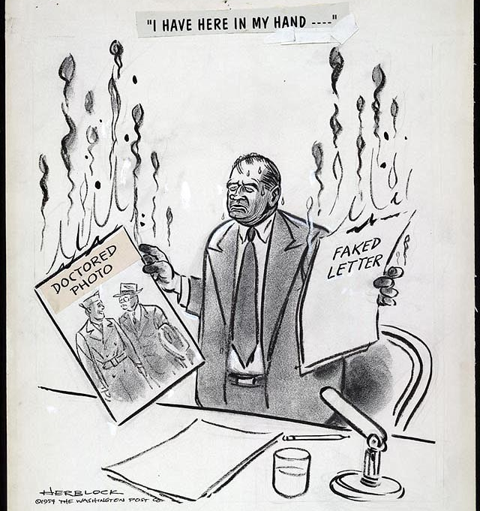
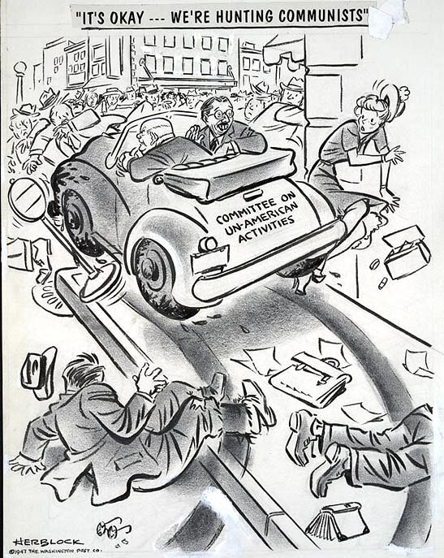
Article Summary (AS) Sheet Directions

- For each of the readings/documents, complete a new AS sheet. Write down the reading/document number on the AS sheet.
- Read, and annotate or “mark the text” for each reading using the following suggestions:
  - Think about what you already know about the reading, person, concept, program, etc. before reading each document. This may help you understand bias, meaning, and/or significance.
  - Circle the words you don’t know, and define them to deepen understanding.
  - Underline or highlight the main ideas, historical figures, and/or passages that are meaningful to you and your prompt. Identify causes of the Red Scare and evidence supporting those causes. Make notes of these in your AS, and cite them in your paper.
  - List questions you have and comments/analysis you come up with as you are reading each document, then summarize your comments within your AS. (Each AS should have at least three questions and/or analyzing comments within them to demonstrate your efforts.)
  - Bracket, put an asterisk next to, or somehow identify the thesis/main ideas of the reading within each document.
- REMEMBER to keep track of your readings and your AS’s! You will need them during class, you may receive grades upon the correct completion of each of them, and you must use them as your references and notes while you are writing your argumentative essay.
Your rough draft is due on ________________________. Your final draft will be due a week after your rough draft is returned to you. Be sure not to fall behind our pacing in class!
IN TOTAL, THIS WRITING ASSIGNMENT (including daily grades) WILL BE WORTH ROUGHLY _______POINTS. Also, the combined score of your rough and final drafts will be considered your unit assessment of these concepts. Give it your best effort, and good luck!

DOCUMENT # ______

Article Summary Sheet
Document title:

Source information, including author, date, type of document, and audience. (Who wrote or created this? When? What kind of document is it? Who is the audience?)

Describe any known perspective/purpose.

BRIEF SUMMARY. In your own words, discuss the main points/arguments the document provides. Include important facts/figures and YOUR analysis.

SPECIFIC QUOTATIONS/information/points of view that may be used as supports or counterarguments within my paper.

Document 1: President Truman Executive Order 9835 – Loyalty Order
Headnote: In March of 1947, President Harry S. Truman signed this Executive Order. Executive orders have the force of law and must connect to a power of the executive branch as outlined in the Constitution. They do not require Congressional approval.
PART V—STANDARDS
- The standard for the refusal of employment or the removal from employment in an executive department or agency on grounds relating to loyalty shall be that, on all the evidence, reasonable grounds exist for belief that the person involved is disloyal to the Government of the United States.
- Activities and associations of an applicant or employee which may be considered in connection with the determination of disloyalty may include one or more of the following:
  - Sabotage [deliberate destruction], espionage, or attempts or preparations therefor, or knowingly associating with spies or saboteurs;
  - Treason or sedition or advocacy thereof;
  - Advocacy of revolution or force or violence to alter the constitutional form of government of the United States;
  - Intentional, unauthorized disclosure to any person, under circumstances which may indicate disloyalty to the United States, of documents or information of a confidential or non-public character obtained by the person making the disclosure as a result of his employment by the Government of the United States;
  - Performing or attempting to perform his duties, or otherwise acting, so as to serve the interests of another government in preference to the interests of the United States.
  - Membership in, affiliation with or sympathetic association with any foreign or domestic organization, association, movement, group or combination of persons, designated by the Attorney General as totalitarian, fascist, communist, or subversive, or as having adopted a policy of advocating or approving the commission of acts of force or violence to deny other persons their rights under the Constitution of the United States, or as seeking to alter the form of government of the United States by unconstitutional means.

Source: Excerpt from Executive Order 9835, signed by President Truman on March 21, 1947, and titled, Prescribing Procedures for the Administration of an Employees Loyalty Program in the Executive Branch of the Government.

Document 2: McCarthy’s Wheeling Speech
Headnote: Wisconsin Republican Joseph R. McCarthy first won election to the Senate in 1946 during a campaign marked by much anticommunist Red-baiting. In his famous 1950 speech, Senator McCarthy attacked the State Department (the part of the Executive branch that oversees foreign relations) and its Secretary, Dean Acheson, and accused them of harboring Communists.
Six years ago, . . . there was within the Soviet orbit, 180,000,000 people. Lined up on the antitotalitarian side there were in the world at that time, roughly 1,625,000,000 people. Today, only six years later, there are 800,000,000 people under the absolute domination of Soviet Russia—an increase of over 400 percent. On our side, the figure has shrunk to around 500,000,000. In other words, in less than six years, the odds have changed from 9 to 1 in our favor to 8 to 5 against us.
This indicates the swiftness of the tempo of Communist victories and American defeats in the cold war. As one of our outstanding historical figures once said, “When a great democracy is destroyed, it will not be from enemies from without, but rather because of enemies from within.” The truth of this statement is becoming terrifyingly clear as we see this country each day losing on every front. . . .
The reason why we find ourselves in a position of impotency [powerlessness] is not because our only powerful potential enemy has sent men to invade our shores, but rather because of the traitorous actions of those who have been treated so well by this Nation. It has not been the less fortunate, or members of minority groups who have been selling this Nation out, but rather those who have had all the benefits that the wealthiest Nation on earth has had to offer--the finest homes, the finest college education and the finest jobs in government we can give.
This is glaringly true in the State Department. There the bright young men who are born with silver spoons in their mouths are the ones who have been most traitorous. . . .
I have in my hand 57 cases of individuals who would appear to be either card-carrying members or certainly loyal to the Communist Party, but who nevertheless are still helping to shape our foreign policy.
One thing to remember in discussing the communists in our government is that we are not dealing with spies who get 30 pieces of silver to steal the blueprints of new weapons. We are dealing with a far more sinister type of activity because it permits the enemy to guide and shape our policy. . .
As you know, very recently the Secretary of State proclaimed his loyalty to a man guilty of what has always been considered as the most abominable of all crimes—being a traitor to the people who gave him a position of great trust—high treason. . . .
He [The Secretary of State] has lighted the spark which is resulting in a moral uprising and will end only when the whole sorry mess of twisted, warped thinkers are swept from the national scene so that we may have a new birth of honesty and decency in government.
Source: Excerpt from Senator Joseph McCarthy’s speech made on February 9, 1950, in Wheeling, West Virginia.
Document 3: J. Edgar Hoover’s Speech Before HUAC
Headnote: J. Edgar Hoover was the first director of the Federal Bureau of Investigation (FBI) and would serve in that position from 1924-1972. During that time, the FBI gathered information about many Americans whom the Bureau considered to have dangerous beliefs. Here Hoover talks to the House Committee on un-American Activities (HUAC), where he warned against Communist propaganda and identified specific threats.
The aims and responsibilities of the House Committee on un-American Activities and the Federal Bureau of Investigation are the same–the protection of the internal security of this nation. …
The [Communist] party has departed from depending upon the printed word as its medium of propaganda and has taken to the air. Its members and sympathizers have not only infiltrated the airways but they are now persistently seeking radio channels.
The American Communists launched a furtive attack on Hollywood in 1935 by the issuance of directive calling for a concentration in Hollywood. The orders called for action on two fronts: (1) an effort to infiltrate the labor unions; (2) infiltrate the so-called intellectual and creative fields.
In movie circles, Communists developed an effective defense a few years ago in meeting criticism. They would counter with the question, “After all, what is the matter with communism?” It was effective because many persons did not possess adequate knowledge of the subject to give an intelligent answer.
Some producers and studio heads realized the possibility that the entire industry faces serious embarrassment because it could become a springboard for Communist activities. Communist activity in Hollywood is effective and is furthered by Communists and sympathizers using the prestige of prominent persons to serve, often unwittingly, the Communist cause. The party is content and highly pleased if it is possible to have inserted in a picture a line, a scene, a sequence conveying the Communist lesson and, more particularly, if they can keep out anti-Communist lessons.
Source: Excerpt from J. Edgar Hoover, speech before HUAC, March 26, 1947.

Document 4: Duck and Cover—Bert the Turtle
Headnote: “Duck and Cover” is a social guidance film produced in 1951 by the United States federal government's Civil Defense branch shortly after the Soviet Union began nuclear testing. Made with the help of schoolchildren from New York City and Astoria, New York, it was shown in schools as the cornerstone of the government's "duck and cover" public awareness campaign.
https://archive.org/details/gov.ntis.ava11109vnb1
Additional location: http://www.youtube.com/watch?v=IKqXu-5jw60
Source: Produced by the Federal Civil Defense Administration, 1951. Written by Raymond J. Mauer and directed by Anthony Rizzo of Archer Productions.

Document 5: Truman Doctrine (Modified)
The peoples of a number of countries of the world have recently had totalitarian regimes forced upon them against their will. The Government of the United States has made frequent protests against coercion and intimidation in violation of the Yalta agreement in Poland, Rumania, and Bulgaria.
At the present moment in world history nearly every nation must choose between alternative ways of life. The choice is too often not a free one. One way of life is based upon the will of the majority, and is distinguished by free institutions, representative government, free elections, guarantees of individual liberty, freedom of speech and religion, and freedom from political oppression. The second way of life is based upon the will of a minority forcibly imposed upon the majority. It relies upon terror and oppression, a controlled press and radio, fixed elections, and the suppression of personal freedoms.
I believe that it must be the policy of the United States to support free peoples who are resisting attempted subjugation by armed minorities or by outside pressures.
I believe that our help should be primarily through economic and financial aid which is essential to economic stability and orderly political processes.
The free peoples of the world look to us for support in maintaining their freedoms. If we falter in our leadership, we may endanger the peace of the world. And we shall surely endanger the welfare of this nation.
Great responsibilities have been placed upon us by the swift movement of events.
Source: Excerpt from the “Truman Doctrine Speech,” delivered by President Truman to Congress on March 12, 1947.

Document 6: Political Cartoon
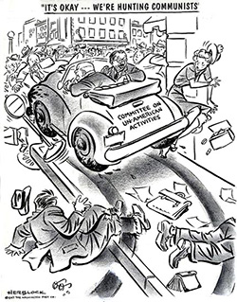

Source: Created by Herb Block, published in the Washington Post, October 31, 1947.

Document 7: Political Cartoon
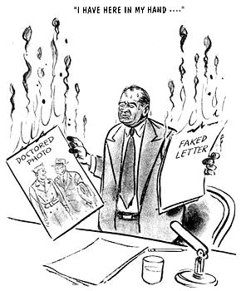

Source: Created by Herb Block, published in the Washington Post, May 7, 1954.

Bibliography
Wheeling Speech: http://historymatters.gmu.edu/d/6456
Duck and Cover: https://archive.org/details/gov.ntis.ava11109vnb1
Cartoon 1: http://www.loc.gov/pictures/item/00652190/
Cartoon 2: http://www.loc.gov/pictures/item/00652203/
Truman Doctrine, from RLH curriculum: http://sheg.stanford.edu/the-cold-war

Choose Your Side
What were the most important causes of the Red Scare after WWII? After reading the primary sources write an essay in which you address the question and argue the role of Senator Joseph McCarthy in this event. Support your answer with evidence from the texts.
Demand 1: Be sure to (acknowledge; refute) competing views.

Claim: Create a statement that responds to the question.

- What was the primary cause or causes of the Red Scare?

- How did Senator Joseph McCarthy increase the fear of communism?

- Claim: While _________________________________ (insert less important cause) increased the fear of communism through ___________________________________________ (insert evidence of how this cause increased fear), the primary causes of the Red Scare in the United States post-war era were

Using the Article Summary pages, decide whether the evidence from the text supports your claim or refutes your claim.
Document number and title or author | What position does it support? | Evidence from the text | How does the evidence support or refute your argument?

Outlining: A Web Method
Directions: Fill out each circle or box with the information that you wish to include in your paper. Then place a support, quote, fact or piece of evidence and the end of each arrow. Be sure to make one of your boxes about your counterclaim.
Introduction

Point one
Point two
Webbing
Conclusion
Point four
Thesis
Point three
Essay Planner
Organizing Notes

Create a short constructed response answering the question.

What topics/categories will you focus on in your essay? Use the spaces provided to place the main points of the different topics that will be in your essay.

Essay Planner

TASK PROMPT:

Introductory Paragraph
Hook:

Background information/context:

Thesis/controlling idea or claim:

Body Paragraph 1
Topic sentence or claim:

Evidence from the text:

Analysis—how this evidence proves/shows my idea:

Body Paragraph 2
Topic sentence or claim:

Evidence from the text:

Analysis—how this evidence proves/shows my idea:

Body Paragraph 3—your counterclaim
Topic Sentence or counterclaim:

Evidence from the text:

Analysis—why your argument trumps this counterclaim and evidence:

Conclusion—stress the importance of the thesis statement
Give the essay a sense of completeness/leave a final impression on the reader:

A Thesis Statement
- tells the reader how you will interpret the significance of the subject matter being discussed.
- is a road map for the paper; in other words, it tells the reader what to expect from the rest of the paper.
- directly answers the question asked of you. A thesis is an interpretation of a question or subject, not the subject itself. The subject, or topic, of an essay might be World War II or Moby Dick—a thesis must then offer a way to understand the war or the novel.
- makes a claim that others might dispute.
- is usually a single sentence somewhere in your first paragraph that presents your argument to the reader. The rest of the paper, the body of the essay, gathers and organizes evidence that will persuade the reader of the logic of your interpretation.

