**Cartoon Analysis Rubric**

OUTCOME

Student can analyze primary and secondary accounts to form an evidence-based interpretation of a historical or contemporary topic/issue.

|  |  |
| --- | --- |
| **Standard: Student can evaluate a political cartoon for point of view using context.** | |
| 3 | Student can **evaluate the historical context** and **provide evidence** to **accurately identify** the perspective of the artist. |
| 2 | Student **can identify** the perspective of the artist but includes **minimal** historical context and evidence. |
| 1 | Student **attempts to** identify the perspective of the artist and address the historical context or supporting evidence. |
| 0 | Student **does** **not** identify the perspective of the artist and needs to include historical context and evidence. |

Name:______________________

**Cartoon Analysis Worksheet: “It’s okay—we’re hunting communists”**

|  |  |  |  |
| --- | --- | --- | --- |
| **Source** | | **Occasion** | |
| 1a. Who is the person who *produced* this work? | | 2a. What is the time and place of the cartoon? | |
| 1b. Who *published* this work? | | 2b. Why is the time and place of the cartoon important? (Historical context) | |
| **Subject** | | | |
| 3. What is the general topic of this cartoon? | | | |
| **Symbols/Metaphors/Distortion** | | | |
| 4a. Identify any symbols and what they mean. | 4b. Identify distortions, stereotypes, and caricatures within the cartoon and what they represent. | | 4c. List clues (words, places, numbers) used in the cartoon. |
| **Purpose** | | | |
| 1. Using the evidence from the cartoon,    1. Identify the perspective of the artist; and    2. Evaluate the impact of the historical context on that perspective. | | | |

**The Cartoon Analysis Checklist**

|  |  |
| --- | --- |
| VISUAL SYMBOLS AND METAPHORS  A visual symbol in a cartoon is any image that stands for some other thing, event, person, abstract idea or trend in the news. For example, a dollar sign may stand for the entire economy. An octopus may stand for a powerful corporation with “tentacles” controlling many other institutions. Metaphors are like symbols in that they describe one thing as something else entirely. Shakespeare used a metaphor when he wrote “All the world’s a stage.” (A cartoon would simply show the world as a stage.) | * Begin any cartoon analysis by describing all the details in it that are symbols and metaphors. |
| VISUAL DISTORTION  Changes or exaggerations in size, shape, emotions or gestures often add extra meaning to the symbols the cartoon includes. For example, a dragon is often used as a symbol for China. But a huge, snorting dragon will make a different point about China from a tired, limping, meek dragon. Every detail in a cartoon, especially one that is distorted in some way, is likely to be a part of the cartoon’s meaning. | * Identify the cartoon’s symbols and notice how they are drawn. |
| IRONY IN WORDS AND IMAGES  Irony is a form of humor in which something is said in a way that undercuts or mocks its own apparent meaning. In other words, what is said seems to mean one thing, but it will be taken to mean the opposite. Irony is well suited to political cartoons, which often seek to mock something and show how false, unfair or dangerous it is. Irony always entails a contradiction. Often, an amusing image undercuts and reverses the meaning of the words in a caption. Sometimes, however, the image alone conveys the double meaning. | * Consider whether irony is used and if so, how? |
| STEREOTYPES AND CARICATURE  A stereotype is a vastly oversimplified view of some group. Stereotypes are often insulting. Yet they may give cartoons a shorthand way to make a complex point quickly. They also reveal broad cultural attitudes. Caricature is the opposite of a stereotype. It is an exaggerated or distorted drawing of an individual highlighting what the artist sees as most unique about that individual. You should be critical of cartoon stereotyping, yet also notice how it contributes to making a point dramatically and forcefully. If there are stereotypes in the cartoon you are analyzing, how would you evaluate them? | * Identify any stereotypes and caricatures and consider what they communicate. |
| AN ARGUMENT NOT A SLOGAN  Slogans merely assert something. “An apple a day keeps the doctor away.” A good editorial cartoon is more than a slogan. Though blunt and opinionated, it actually invites you to consider its argument or its reasoning. At its best, a cartoon offers visual and written features that together “make its case.” In other words, it presents reasons to support its view, or at least it hints at or suggests those reasons. So even though it is biased, the cartoon gives you grounds for responding and even arguing back. | * Consider what features of the cartoon help present its argument or make its case. |
| THE USES AND MISUSES OF POLITICAL CARTOONS  Editorial cartoons may be funny, outrageous, even insulting. Yet above all, their aim is to provoke thought about some issue in the news. They cannot be taken as simple reflections of “the way things were.” Yet that is a common misuse of them. They reveal cultural assumptions, prevailing moods, even real insights about events and trends. They can be used as evidence of all these things. | * Political cartoons always represent points of view that can be challenged. |

Source: <http://teachinghistory.org/teaching-materials/teaching-guides/21733> 

**Cartoon 1 for Practice/Introduction**

[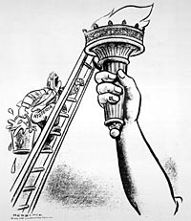](http://www.loc.gov/exhibits/herblocks-history/images/hblock2.jpg)"Fire!"

Created by Herb Block. Published in theWashington Post (25) June 17, 1949. Reproduction from original drawing.

Link for enlarged picture: <http://www.loc.gov/exhibits/herblocks-history/fire.html> 

**Cartoon 2 for Common Assignment Student Work Sample**

[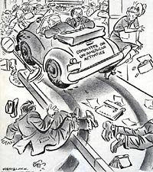](http://www.loc.gov/exhibits/herblocks-history/images/s03380u.jpg)“It’s Okay…We’re Hunting Communists”

Created by Herb Block. Published in the Washington Post (18) October 31, 1947. Ink, graphite, and opaque white over graphite underdrawing on layered paper. [LC-USZ62-127327](http://www.loc.gov/exhibits/herblocks-history/object.html#repro) 

Link for enlarged picture: <http://www.loc.gov/pictures/item/00652190> 

**“Communism McCarthy Cartoons” PowerPoint**

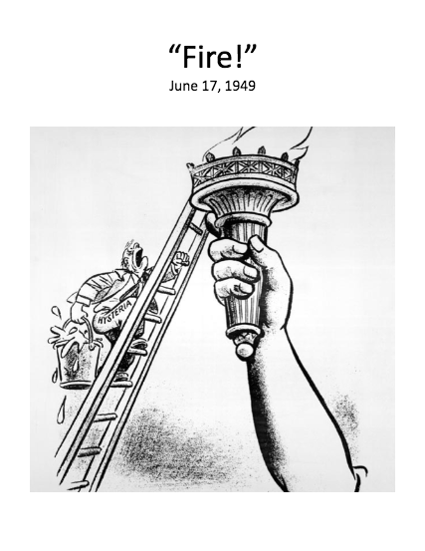

**Access the full PowerPoint here:** [http://collegeready.gatesfoundation.org/wp-content/uploads/2015/06/HS-History-Cold-War-Communism-McCarthy-  
Cartoons.pptx](http://collegeready.gatesfoundation.org/wp-content/uploads/2015/06/HS-History-Cold-War-Communism-McCarthy-Cartoons.pptx) 