**Analyzing Human Impacts on Population Dynamics**

Outdoor Lab Activity—Biology

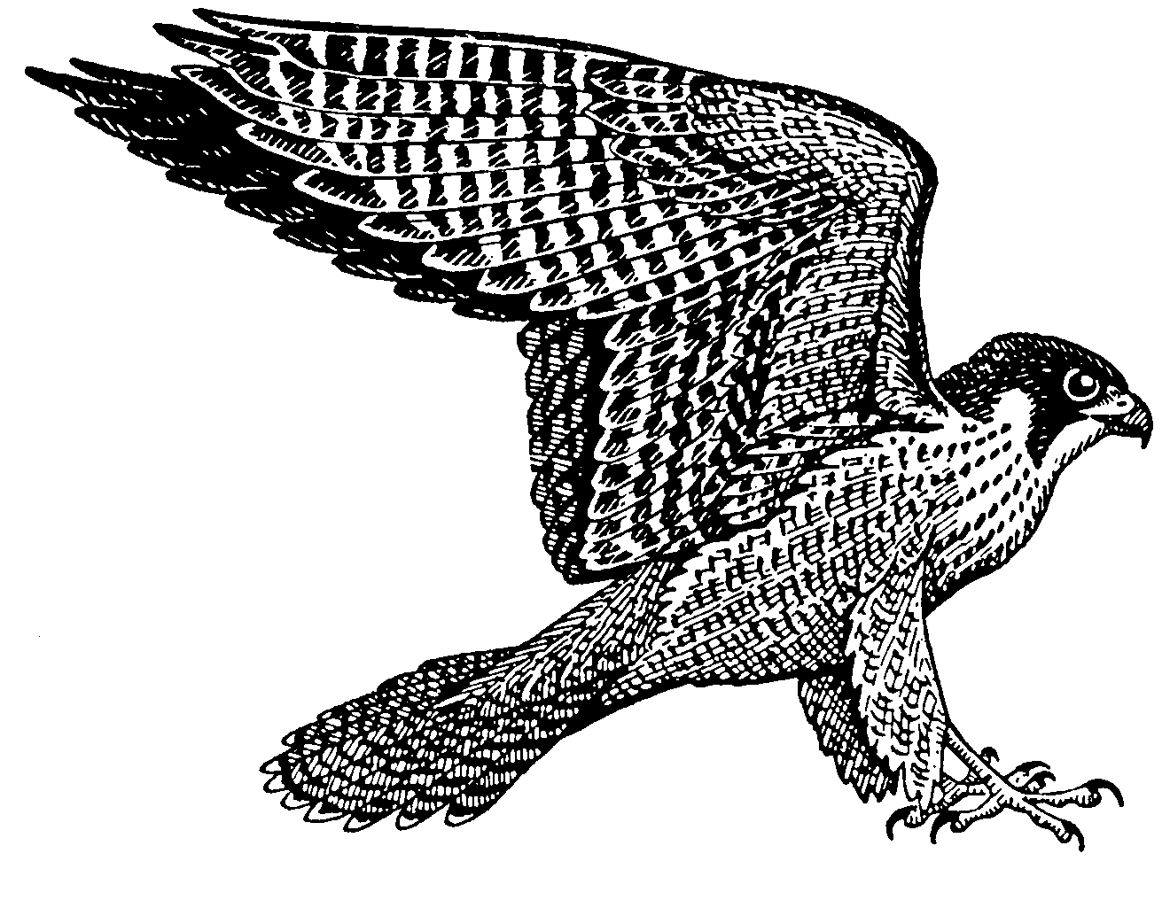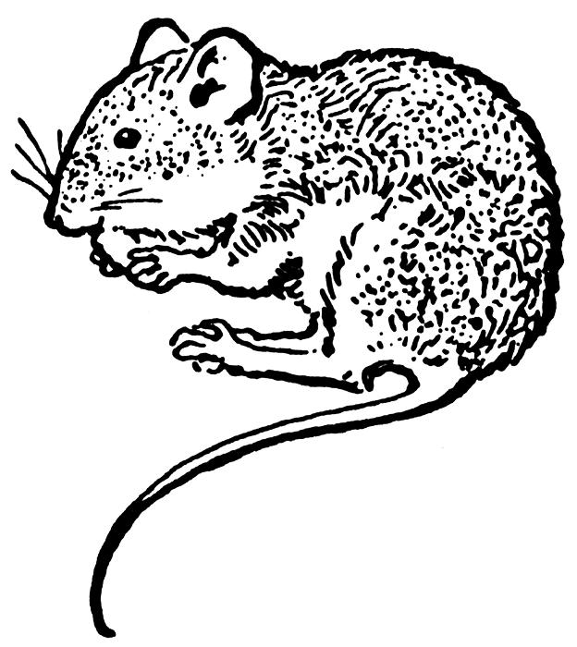

Introduction

The populations of various organisms in an ecosystem can be impacted both directly and indirectly by human interaction. Four examples of human impact on population dynamics that will be analyzed in this lab include: (1) accidental introduction of disease, (2) accidental introduction of invasive species, (3) changes in predator-prey relationship, and (4) habitat loss.

An ecosystem is home to many species, and within an ecosystem there are various food chains. In this lab, your group will be acting as mice, working to gather food for your mouse population back at the nest. Your population will experience various changes that affect not only your population of mice, but also other organism populations in your area. You will each be given an area that will serve as your ecosystem. Once you have collected food and fed your population, the hawks will feed on your growing population of mice.

For your ecosystem, this is how organisms are fed:

**Three beans will feed one mouse**

**Four mice will feed one hawk**

Pre-Lab Questions

1. Based on the introduction given above, develop a hypothesis that explains the relationship of population dynamics to direct/indirect human impact.
2. Based on the organisms described in the lab, identify the producers, primary consumers, and secondary consumers.
   1. **Producers** =
   2. **Primary consumers** =
   3. **Secondary consumers** =
3. Using your answers from question 2, start with ***1,000 J*** at the first trophic level and construct an energy pyramid with the correct energy quantities at each level.

Materials

Each group will need the following:

* Plastic cup
* String
* Meter sticks/rulers
* Four plot markers (skewers)
* Tweezers (optional)
* Lentils/split peas
* White beans
* Stopwatch
* Calculator

Procedure

Scenario 1—Normal Conditions

* Measure out a **two-meter by two-meter**plot of grass on the lawn. Mark your plot with the yarn provided. This area is your ecosystem!
* Spread your beans throughout your plot of land.
* Three team members will be gathering beans using their hands for **one minute.** Each “mouse” can only pick up **one bean at a time.**
* After one minute is up, count the total number of beans collected and record this number in the data chart below.

|  |  |  |  |  |  |  |  |
| --- | --- | --- | --- | --- | --- | --- | --- |
| **1** | **No. of Beans Collected** | **No. of Mice**  *(3 beans = 1 mouse)* | **No. of Hawks**  *(4 mice = 1 hawk)* | **Total No. of Organisms** *(community****)*** | **Area** | **Total Mouse Population Density** | **Total Hawk Population Density** |
| **Group**  **Trial** |  |  |  |  |  |  |  |
| **Class Average** |  |  |  |  |  |  |  |

* Using the number of beans recorded in the data table above, **calculate the number of mice, hawks, and total number of organisms.** When calculating, **round down** to the nearest whole number. Do not worry about population density just yet, you will calculate this later!
* **Sprinkle** the beans back into your ecosystem. This will happen each time you are finished gathering food, thereby representing reproduction of your bean plants each year.

Scenario 2—Disease Conditions

Oh, no! A group of local hikers have recently returned from a cross-country trip and brought back some unexpected hitchhikers on their boots—a fungus that makes many of your mice too sick to gather food for your population. Therefore, **only one mouse is left to do all the collecting.**

* One person in the group will collect beans for another full minute.
* After one minute is up, count the beans collected and record this number in the data chart below. Using this number of beans, calculate the number of mice, hawks, and total number of organisms.
* **Sprinkle** these beans back into your ecosystem.

|  |  |  |  |  |  |  |  |
| --- | --- | --- | --- | --- | --- | --- | --- |
| **2** | **No. of Beans Collected** | **No. of Mice**  *(3 beans = 1 mouse)* | **No. of Hawks**  *(4 mice = 1 hawk)* | **Total No. of Organisms** *(community****)*** | **Area** | **Total Mouse Population Density** | **Total Hawk Population Density** |
| **Group**  **Trial** |  |  |  |  |  |  |  |
| **Class Average** |  |  |  |  |  |  |  |

Scenario 3—Invasive Species Introduction

It seems that your poor mice population cannot catch a break! A truck illegally dumped fill-dirt into your field, completely unaware that the dirt contained a non-native worm species. This particular species begins to feed off the roots of the white beans your population of mice depends upon! Although your sick mice have recovered from the recent fungus outbreak, your food supply is cut short and you can only gather the **green beans** for food.

* **All the group members** who collected food in scenario 1 will **collect only the green beans** for one minute.
* After one minute is up, count the beans collected and record this number in the data chart below. Using this number of beans, calculate the number of mice, hawks, and total number of organisms.
* **Sprinkle** these beans back into your ecosystem.

|  |  |  |  |  |  |  |  |
| --- | --- | --- | --- | --- | --- | --- | --- |
| **3** | **No. of Beans Collected** | **No. of Mice**  *(3 beans = 1 mouse)* | **No. of Hawks**  *(4 mice = 1 hawk)* | **Total No. of Organisms** *(community****)*** | **Area** | **Total Mouse Population Density** | **Total Hawk Population Density** |
| **Group**  **Trial** |  |  |  |  |  |  |  |
| **Class Average** |  |  |  |  |  |  |  |

Scenario 4—Predator Increase

A group of people have shown up and cut the grass in your field—you feel so exposed! You can no longer hide from predators in patches of tall grass when you are out collecting food. Consequently, the hawks in the area have taken notice and are increasing in number. As a result of the changing ecosystem, your equations for determining population numbers have changed. Since gathering food is now more difficult, the mice need double the energy/food to survive. Because of less cover, the hawks, on the other hand, require half the energy to hunt and therefore need less food to survive. **Don’t forget,** those pesky invasive worms are still eating up your white bean supply. **You must continue to only collect the green beans.**

* **All the group members** who collected food in scenario 1 will collect **only green beans** for one minute.
* After one minute is up, count the beans collected and record this number in the data chart below. Using this number of beans, calculate the number of mice, hawks, and total number of organisms.
* **Sprinkle** these beans back into your ecosystem.

Your **NEW** food totals are as follows:  
**Six beans will feed one mouse  
Two mice will feed one hawk**

|  |  |  |  |  |  |  |  |
| --- | --- | --- | --- | --- | --- | --- | --- |
| **4** | **No. of Beans Collected** | **No. of Mice**  *(6 beans = 1 mouse)* | **No. of Hawks**  *(2 mice = 1 hawk)* | **Total No. of Organisms** *(community****)*** | **Area** | **Total Mouse Population Density** | **Total Hawk Population Density** |
| **Group**  **Trial** |  |  |  |  |  |  |  |
| **Class Average** |  |  |  |  |  |  |  |

Scenario 5—Land Development

Your population of mice has figured out why those people cut the grass back so far last year – these crazy humans are building an apartment complex in your field! As a result of this habitat loss, the area of your ecosystem has been significantly decreased. Your two-meter by two-meter plot of land is now decreased to one meter by one meter. Again, remember that the worm species is still present in your ecosystem and so you can still **only** collect green beans.

* **All the group members** who collected food in scenario 1 will collect **only green colored** **beans** for one minute. Make sure to have the young mouse keep time again!
* After one minute is up, count the beans collected and record this number in the data chart below. **Continue to use the food calculations given in scenario 4.**
* Pick up all remaining beans in your plot, clean up the area, and return all supplies to your teacher.

|  |  |  |  |  |  |  |  |
| --- | --- | --- | --- | --- | --- | --- | --- |
| **5** | **No. of Beans Collected** | **No. of Mice**  *(6 beans = 1 mouse)* | **No. of Hawks**  *(2 mice = 1 hawk)* | **Total No. of Organisms** *(community****)*** | **Area** | **Total Mouse Population Density** | **Total Hawk Population Density** |
| **Group**  **Trial** |  |  |  |  |  |  |  |
| **Class Average** |  |  |  |  |  |  |  |

Data Analysis

Once you have finished collecting beans across all 5 scenarios, calculate the area for your plot of land and use this number to determine the population density of hawks and mice for your ecosystem.

**AREA = length x width**

**POPULATION DENSITY = population/area**

1. Plot the **population density** numbers for **both** hawks and mice across each scenario in the graph provided below. Make sure to include title, axis labels (with proper scale), and units.
2. Pick **two** scenarios and compare the population density data from these two scenarios to that of scenario 1 (normal conditions). Using the data from your graph, **make inferences** about your findings (trends, similarities, differences, etc.).
3. Based on the data, do you accept or reject your initial hypothesis stated in question 1? **Justify your answer.**

Drawing Conclusions

1. Choose **one** of the human impacts mentioned in the lab and design a solution for reducing or **mitigating** those impacts of human activities. **Explain** how your solution will mitigate the impacts.
2. **Explain** two possible sources of error in the lab procedure **and** the impact of error on your data. (Meaning, what do you think did **NOT** work or was possibly confusing about this lab, and how did it affect your work?)

Application—Apply What You Have Learned!

Using the graph *on the next page,* answer the following questions.

1. Which **species of mussel** was present in this waterway in 1991?
2. What was the **population density** of unionids in 1998?
3. What was the **population density** of the zebra mussels in 1993?
4. Which of these species is the **invasive species**? Use data to **support** your answer.
5. Explain **two** different ways that the invasive species may bring about the decline of the native species.

Data taken from <http://www.caryinstitute.org/educators/teaching-materials/changing-hudson-project/zebra-mussel-invasion-data> , accessed 7/22/2014